**About**

**the University**

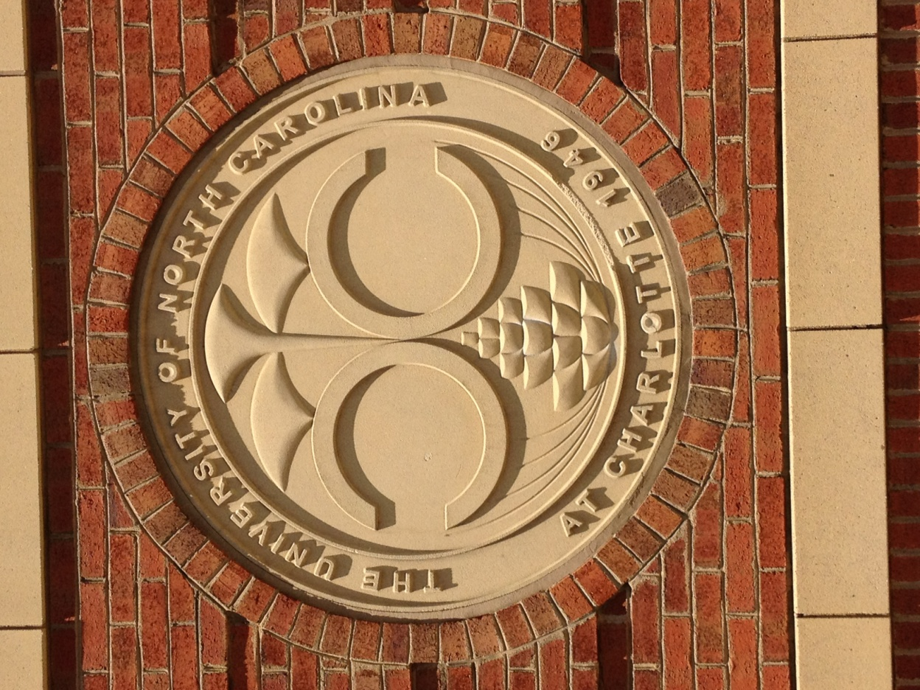

**The University of North Carolina System**

**www.northcarolina.edu**

In North Carolina, all of the public educational institutions that grant baccalaureate degrees are part of The University of North Carolina System. The oldest public university system in the nation, UNC traces its roots to the state’s 1776 constitution, which held that “All useful Learning shall be duly encouraged and promoted in one or more Universities.” Today, nearly 225,000 students are enrolled on 16 university campuses across the state and at the NC School of Science and Mathematics, the country’s first public, residential high school for gifted students.



**History**

Chartered by the North Carolina General Assembly in 1789, the University of North Carolina was the first public university in the United States to open its doors and the only one to graduate students in the eighteenth century. The first class was admitted in Chapel Hill in 1795. For the next 136 years, the only campus of the University of North Carolina was at Chapel Hill.

Additional institutions of higher education, diverse in origin and purpose, began to win sponsorship from the General Assembly beginning as early as 1877. Five were historically black institutions, and another was founded to educate Native Americans. Some began as high schools. Several were created to prepare teachers for the public schools. Others had a technological emphasis. One is a training school for performing artists.

The 1931 session of the General Assembly redefined the University of North Carolina to include three state-supported institutions: (1) the campus at Chapel Hill (now the University of North Carolina at Chapel Hill), (2) North Carolina State College (now North Carolina State University at Raleigh), and (3) Woman's College (now the University of North Carolina at Greensboro). The new multi-campus University operated with one board of trustees and one president. By 1969, three additional campuses had joined the University through legislative action: (4) the University of North Carolina at Charlotte, (5) the University of North Carolina at Asheville, and (6) the University of North Carolina at Wilmington.

In 1971, legislation was passed bringing into the University of North Carolina the state's ten remaining public senior institutions, each of which had until then been legally separate: (7) Appalachian State University, (8) East Carolina University, (9) Elizabeth City State University, (10) Fayetteville State University, (11) North Carolina Agricultural and Technical State University, (12) North Carolina Central University, (13) the North Carolina School of the Arts (now the University of North Carolina School of the Arts), (14) Pembroke State University (now the University of North Carolina at Pembroke), (15) Western Carolina University, and (16) Winston-Salem State University. In 1985, the NC School of Science and Mathematics was declared an affiliated school of the University; in July 2007, NCSSM by legislative action became a constituent institution of the University of North Carolina.

**Board of Governors**

The UNC Board of Governors is the policy-making body charged with “the general determination, control, supervision, management, and governance” of the University of North Carolina. Its 28 voting members are elected by the NC General Assembly for four-year terms. Former board chairs may continue to serve for limited periods as non-voting members emeriti. The president of the UNC Association of Student Governments or that student’s designee is also a non-voting member.

**President and UNC System Office**

The chief executive officer of the University of North Carolina System is the President. The President is elected by and reports to the Board of Governors. The President’s office is the operations level between the constituent institutions and the Board of Governors. The President has complete authority to manage the affairs and execute the policies of the University of North Carolina and its constituent institutions, subject to the direction and control of the Board of Governors.

**Chancellors**

Each of the UNC campuses is headed by a Chancellor who is chosen by the Board of Governors on the President's nomination and is responsible to the President.

**Board of Trustees**

Each UNC campus has a local Board of Trustees that holds extensive powers over academic and other operations of its campus on delegation from the Board of Governors.

**Shared Governance**

The UNC System operates under an arrangement of shared governance that leverages the collective strengths of its campus chancellors and administrators, local boards of trustees, and the UNC President and Board of Governors. The UNC System also honors the important traditional role of the faculty in the governance of the academy.

**History of the**

**University of North Carolina at Charlotte**

**www.charlotte.edu**

UNC Charlotte is one of a generation of universities founded in metropolitan areas of the United States immediately after World War II in response to rising education demands generated by the war and its technology.

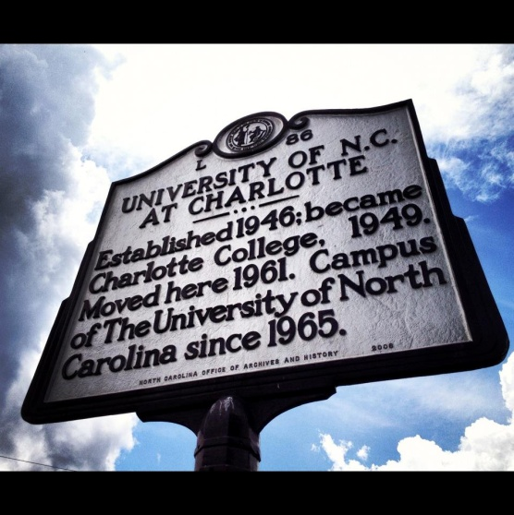To serve returning veterans, North Carolina opened 14 evening college centers in communities across the state. The Charlotte Center opened Sept. 23, 1946, offering evening classes to 278 freshmen and sophomore students in the facilities of Charlotte’s Central High School. After three years, the state closed the centers, declaring that on-campus facilities were sufficient to meet the needs of returning veterans and recent high school graduates.

Charlotte’s education and business leaders, long aware of the area’s unmet needs for higher education, moved to have the Charlotte Center taken over by the city school district and operated as Charlotte College, offering the first two years of college courses. Later the same leaders asked Charlotte voters to approve a two-cent tax to support that college.

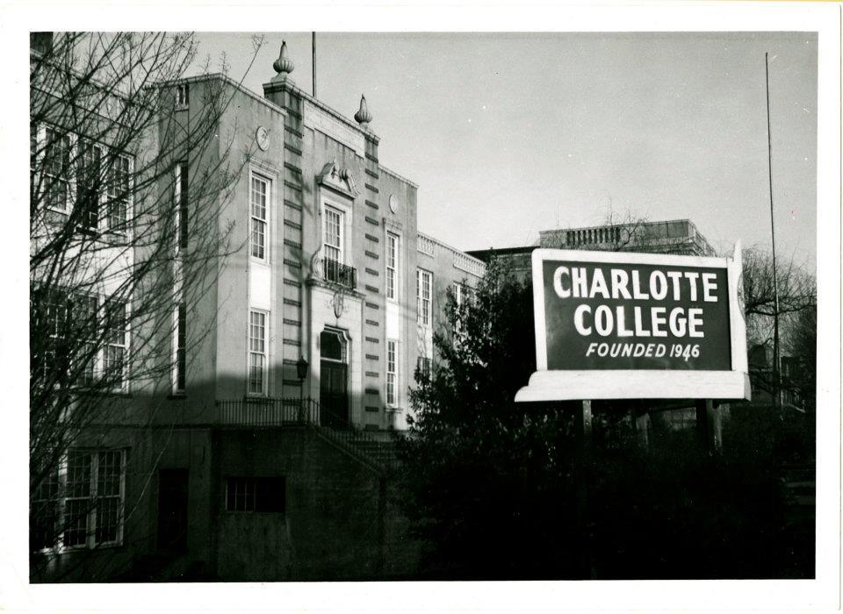

Charlotte College drew students from the city, Mecklenburg County and from a dozen surrounding counties. The two-cent tax was later extended to all of Mecklenburg County. Ultimately financial support for the college became a responsibility of the State of North Carolina.

As soon as Charlotte College was firmly established, efforts were launched to give it a campus of its own. With the backing of Charlotte business leaders and legislators from Mecklenburg and surrounding counties, land was acquired on the northern fringe of the city and bonds were passed to finance new facilities. In 1961, Charlotte College moved its growing student body into two new buildings on what was to become a 1,000-acre campus 10 miles from downtown Charlotte.

Three years later, the North Carolina legislature approved bills making Charlotte College a four-year, state-supported college. The next year, 1965, the legislature approved bills creating the University of North Carolina at Charlotte, the fourth campus of the statewide university system. In 1969, the University began offering programs leading to master’s degrees. In 1992, it was authorized to offer programs leading to doctoral degrees.

Today, with an enrollment ranking it fourth among the 17 schools in the UNC system, it is the largest public university in the greater Charlotte metropolitan region. A doctoral institution, UNC Charlotte serves the region through applied research, knowledge transfer, and engaged community service.

More than 1,100 full-time teaching faculty comprise the University’s academic departments, and the Fall 2021 enrollment was over 30,000 students, including almost 6,300 graduate students.

**Mission, Vision, and Values of**

**UNC Charlotte**

**chancellor.charlotte.edu/institutional-planning/mission-statement**

**University Mission Statement**

As North Carolina’s urban research university, UNC Charlotte is a diverse and inclusive institution with local-to-global impact that transforms lives, communities, and industries through access and affordability, exemplary bachelor’s, master’s, doctoral, and professional programs, scholarship, creative work, innovation, and service.

**University Vision and Values**

In fulfilling our mission, we envision a University that promises:

* An accessible and affordable quality education that equips students with intellectual and professional skills, ethical principles, and an international perspective.
* A strong foundation in liberal arts and opportunities for experiential education to enhance students’ personal and professional growth.
* A robust intellectual environment that values social and cultural diversity, free expression, collegiality, integrity, and mutual respect.
* A safe, diverse, team-oriented, ethically responsible, and respectful workplace environment that develops the professional capacities of our faculty and staff.

To achieve a leadership position in higher education, we will:

* Rigorously assess our progress toward our institutional, academic, and administrative plans using benchmarks appropriate to the goals articulated by our programs and in our plans.
* Serve as faithful stewards of the public and private resources entrusted to us and provide effective and efficient administrative services that exceed the expectations of our diverse constituencies.
* Create meaningful collaborations among university, business, and community leaders to address issues and opportunities of the region.
* Develop an infrastructure that makes learning accessible to those on campus and in our community and supports the scholarly activities of the faculty.
* Pursue opportunities to enhance personal wellness through artistic, athletic, or recreational activities.
* Operate an attractive, environmentally responsible and sustainable campus integrated with the retail and residential neighborhoods that surround us.

*Approved by the Board of Governors on April 11, 2014.*

**Graduation Rate Disclosure Statement**

Our data shows that 69.9% of the full-time new freshmen who entered UNC Charlotte in Fall 2016 have received a baccalaureate from UNC Charlotte as of Fall 2022. In addition, another 2.0% were enrolled at UNC Charlotte in pursuit of their baccalaureate degree as of Fall 2021. This information is provided pursuant to requirements of the Student Right-to-Know and Campus Security Act of 1990.

**Nondiscrimination**

The University of North Carolina at Charlotte is committed to providing a respectful, safe, and inclusive environment for all University community members and guests of the University. The University affirms that its educational and employment decisions must be based on the abilities and qualifications of individuals and may not be based on irrelevant factors, including personal characteristics, that have no connection with academic abilities or job performance. Therefore, the University prohibits discrimination and discriminatory harassment in its educational and employment decisions and provides equal opportunities for all members of the University community and for all those seeking to join the University community.

The following factors may not form the basis for educational or employment-related decisions: race; color; religion, including belief and non-belief; sex; sexual orientation; gender identity; age; national origin; physical or mental disability; veteran status; and genetic information. See University Policy 501, Nondiscrimination, at [legal.charlotte.edu/policies/up-501](https://legal.charlotte.edu/policies/up-501).

Anyone may [report](https://cm.maxient.com/reportingform.php?UNCCharlotte&layout_id=126) alleged violations of University Policy 501 to the University’s [Office of Civil Rights and Title IX](https://civilrights.charlotte.edu/).  All University employees are expected to report alleged violations of this Policy to the University’s Office of Civil Rights and Title IX and may be subject to disciplinary action, up to and including dismissal, for failing to report.

For complaints of Title IX Sexual Harassment (as that term is defined by [University Policy 504, Title IX Grievance Policy](https://legal.charlotte.edu/policies/up-504#IV)) against a student, faculty member, or staff member, see [University Policy 504, Title IX Grievance Policy](https://legal.charlotte.edu/policies/up-504).

The University’s [Office of Civil Rights and Title IX](https://civilrights.charlotte.edu/) will contact the individual who reportedly experienced a violation of this Policy and discuss with the individual available accommodations, resources, and resolution options.  The University’s Office of Civil Rights and Title IX will assist the individual in utilizing the applicable University process for that individual’s report, as set forth on the [Office of Civil Rights and Title IX website](https://civilrights.charlotte.edu/).

The University strictly prohibits retaliation against individuals for reporting alleged violations of federal law or for cooperating in the University’s investigation of alleged violations of federal law. Retaliation includes threatening, intimidating, or coercive behaviors and other adverse actions that would deter a reasonable person in the same or similar circumstances from reporting alleged violations of federal law or cooperating in the University’s investigation of any such report, even if the behaviors do not ultimately have that effect.

If you have discrimination concerns, please see the UNC Charlotte Notice of Nondiscrimination for the contact information of individuals who may assist you.  This notice and the University’s grievance procedures for making a complaint of discrimination may be found online at [legal.charlotte.edu/sites/legal.charlotte.edu/files/media/NondiscriminationNotice.pdf](https://legal.charlotte.edu/sites/legal.charlotte.edu/files/media/NondiscriminationNotice.pdf).

**University Structure**

UNC Charlotte is organized into five administrative divisions: Academic Affairs, Business Affairs, Institutional Integrity, Student Affairs, and University Advancement. These divisions, as well as Athletics, Diversity & Inclusion, OneIT, and Research all report to the Chancellor.

**Academic Affairs**

The Division of Academic Affairs provides administrative oversight and academic leadership. It includes Academic Budget & Personnel, ADVANCE Faculty Affairs and Diversity Office; Enrollment Management; the Graduate School; the Honors College; Institutional Effectiveness and Analytics; International Programs; the Library; Office of Undergraduate Education; School of Professional Studies; urbanCORE; and the seven discipline-based academic colleges: the Colleges of Arts + Architecture, Business, Computing and Informatics, Education, Engineering, Health and Human Services, College of Liberal Arts & Sciences.

**Business Affairs**

Business Affairs plans for and provides essential human, financial, facility, and administrative support services to the University that are customer-focused, results-oriented, fiscally sound, and integrity-bound. The Division of Business Affairs includes Business Services; Facilities Management; Financial Services; Human Resources; Safety and Security; and Budget.

**Institutional Integrity**

The Division of Institutional Integrity supports UNC Charlotte in its endeavors to achieve its academic mission and strategic plan while adhering to the University’s ethical, legal, and regulatory responsibilities. The Division of Institutional Integrity consists of the Office of Legal Affairs, the Office of Ethics, Policy, and Compliance, the Office of Civil Rights and Title IX, the Internal Audit Department, and the Enterprise Risk Management Department.

**Student Affairs**

The Division of Student Affairs advances the educational mission of the University by creating inclusive student-centered learning environments where students excel academically and develop personally into their best selves. The Division of Student Affairs consists of the Center for Counseling and Psychological Services (CAPS); Center for Integrated Care; Center for Wellness Promotion; Cone University Center; Dean of Students Office; Housing and Residence Life; Leadership & Community Engagement; Niner Finances; Office of Fraternity and Sorority Life; Office of Identity, Equity & Engagement; Popp Martin Student Union; Student Accountability &  Conflict Resolution; Student Affairs Marketing & Communications; Student Affairs Research & Assessment; Student Assistance and Support Services; Student Health Center; Student Involvement; Student Niner Media; Advising and Support; Transition & Success Initiatives; UNC Charlotte Student Legal Services, Inc.; University Recreation; Venture Outdoor Leadership; and Veteran Services.

**University Advancement**

The Division of University Advancement supports the mission of the University by cultivating alumni, community, and government support and affinity, by raising funds for scholarships and major initiatives, by providing and coordinating community engagement opportunities, and by providing broad based communications leadership that articulates the mission of the University to the region, state and nation. The Division includes Advancement Operations, Alumni Engagement, Development, University Communications, and University Events & Special Programs.

**Campuses**

**Main Campus**

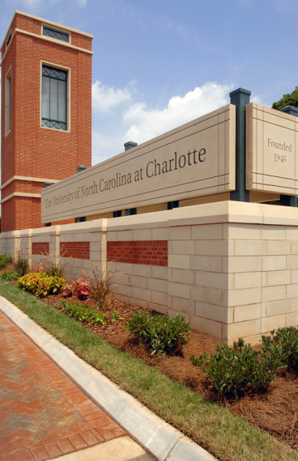The University of North Carolina at Charlotte is the largest institution of higher education in the Charlotte region and is a genuine urban university. The main campus is in University City, one of the fastest growing areas of the Charlotte region, located off WT Harris Boulevard on NC 49 near its intersection with US 29, and only eight miles from the interchange of Interstates 85 and 77. Campus facilities are comprised of contemporary buildings, including many constructed in the past ten years and more on the way. In addition to classrooms and well-equipped laboratories, the University offers arts and athletic facilities, dining facilities, and residence accommodations. The campus is designed for the pedestrian, and facilities are generally accessible to students with disabilities.

**Dubois Center at UNC Charlotte Center City**

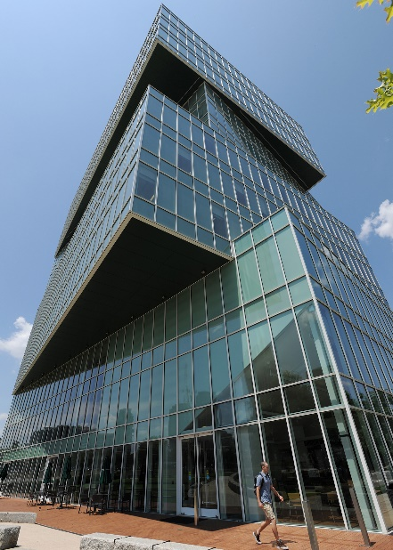The Dubois Center at UNC Charlotte Center City functions as a gateway between the city of Charlotte and the University and as such embodies UNC Charlotte’s urban identity in the heart of the greater Charlotte region. Architecturally, it reflects its mission as a premier institution of higher education; its context in this vibrant, rapidly urbanizing area; and its commitment to environmental sustainability.

Home to the School of Professional Studies, the building bustles with working professionals and adult learners who are able to conveniently access continuing education programs ranging from 1-day workshops, to short-format certificates and boot camps, to degrees.

In addition to professional programming, The Dubois Center facilitates academic programs having an urban awareness and context, while providing vital learning opportunities for employees and residents of the urban center.

Architecturally, it reflects its mission as a premier institution of higher education; its context in this vibrant, rapidly urbanizing area; and its commitment to environmental sustainability.

Operationally, it incorporates the attributes we wish to instill in the entire University: excellence in programming, responsiveness to stakeholders, entrepreneurship, interdisciplinary productivity, inclusively, flexibility, and efficiency.

**Academic Buildings**

**Albert & Freeman**

The Energy Production and Infrastructure Center (EPIC) at UNC Charlotte was formed in response to the need from industry to supply highly trained engineers qualified to meet the demands of the energy industry – through traditional and continuing education, and provide sustainable support the Carolina energy industry by increasing capacity and support for applied research. EPIC is a highly collaborative industry/education partnership that produces a technical workforce, advancements in technology for the global energy industry while supporting the Carolinas' multi-state economic and energy security. It was dedicated on November 16, 2012.

In October 2020, the EPIC building was named the Albert & Freeman Energy Production and Infrastructure Center to recognize and honor alumni Craig and Darla Albert. The generosity of the Alberts, especially throughout Exponential: The Campaign for UNC Charlotte, established both the Albert Engineering Leadership Scholars program and the Freeman Scholarship, both housed in the University’s Honors College.

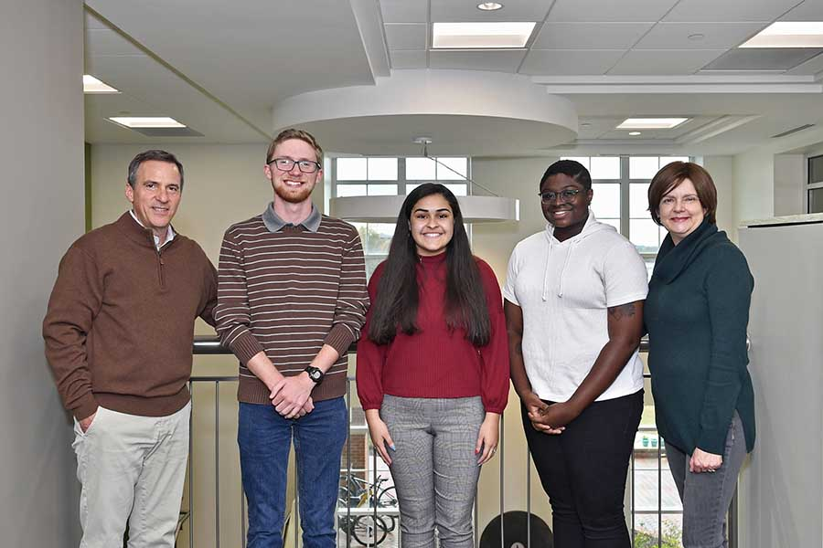

The Albert Engineering Leadership Scholars Program invests in superior students who have demonstrated excellence in the areas of academic achievement, leadership and community engagement. Albert Scholars serve as the next generation of leaders who will make dynamic contributions to the field of engineering. The program offers students a full, four-year scholarship, along with academic support and the professional guidance necessary to achieve their educational and professional goals.

The Freeman Scholarship provides renewable scholarship support to students pursuing any major who are eligible for one of the University’s honors programs. The Freeman Scholarship is open to incoming first-year students eligible for a Federal Pell Grant or other federal grant aid programs. The scholarship places a strong emphasis on commitment to academics.

Craig Albert earned a bachelor’s degree in mechanical engineering from the Lee College of Engineering in 1985 and currently serves as president and chief operating officer of Bechtel Group Inc., the largest engineering and construction firm in the United States. He is responsible for the management and oversight of the firm’s global operations and serves on the company’s board of directors. Darla Albert earned a bachelor’s degree in business administration from UNC Charlotte’s Belk College of Business in 1983.

EPIC is home to the Department of Civil and Environmental Engineering and Department of Electrical and Computer Engineering.

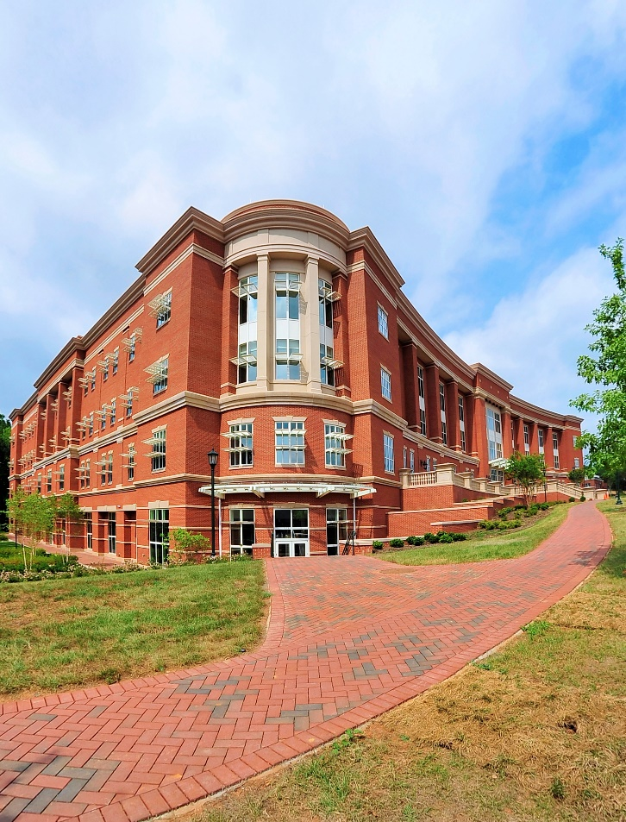

**Atkins Library**

The J. Murrey Atkins Library, the third building to be constructed on the UNC Charlotte campus, is named for J. Murrey Atkins, the son of a prominent Gastonia family, successful Charlotte businessman and one of the University’s founding members.

Atkins, born in Russellville, Kentucky, graduated from Gastonia High School. At Duke University, he served as editor of the yearbook and earned a bachelor’s degree in 1927. He attended Harvard Law School and Columbia University and spent five years in New York with the Irving Trust Co. before returning to Charlotte. In 1935, he joined the city’s leading investment firm R.S. Dickson and Co., where he was president from 1954 until his death.

Atkins was involved with Charlotte College from its inception. He was chair of the college advisory committee for eight years and chair of the Charlotte Community College System when it was authorized in 1958. When UNC Charlotte became a four-year college, he served as chair of the Board of Trustees.

Sensitive to the social and educational needs of the community, Atkins believed that the Charlotte region needed a public institution of higher learning to stay competitive with other cities in the state. He used his business, financial and political contacts to help Charlotte College become that institution. “Charlotte College was started to meet an emergency and has continued as a necessity,” Atkins was fond of saying.

Charlotte College shared a library facility with Central High School. Mozelle Scherger was hired as the first full-time librarian in 1957, when a daytime instructional program was launched. When the college was formally accredited that fall, the number of volumes in the library exceeded 6,000.

Atkins believed the library should be central on the campus, central in student service and the very focal point of learning. When the library was first moved to the new campus, it was temporarily housed in the W. A. Kennedy Building.

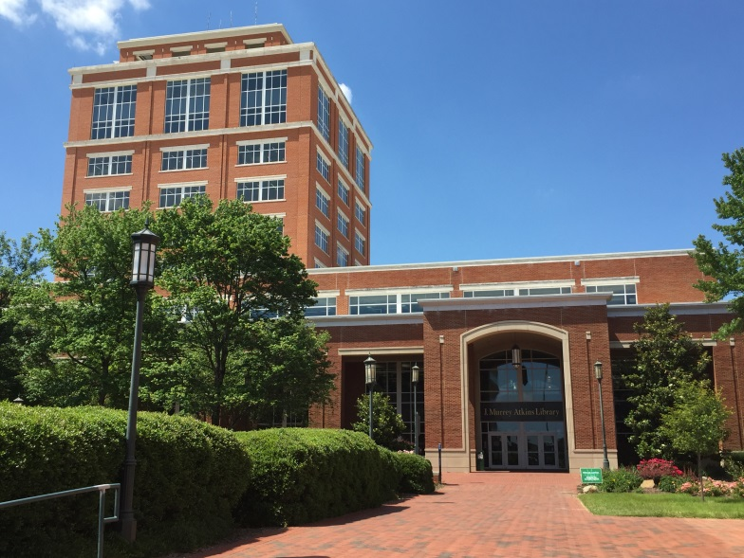

The pioneering leader would not live to see the current library adorned with his name. He died Dec. 2, 1963, and the J. Murrey Atkins Library was dedicated on April 19, 1965. The state legislature appropriated $20.5 million for an expansion in 1995. It was re-dedicated in 2001.

**Dalton Library Tower**

The Harry L. Dalton Library Tower was completed and dedicated in 1971, and re-dedicated in 2001. It is named in honor of Harry Lee Dalton, distinguished Charlotte business leader and patron of the arts, whose gifts stimulated the development of the Library’s Special Collections.

**Barnard**

The Barnard Building was completed in 1969. It is named in honor of Bascom Weaver Barnard, a founder and first chairman of The Charlotte College Foundation, and first executive director of The Foundation of the University of North Carolina at Charlotte.

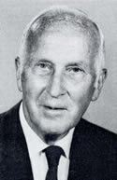Bascom “Barney” Weaver Barnard established the Charlotte College Foundation and served as its first chair. His name features prominently in the early years of UNC Charlotte, and it adorns an 18,000 square-foot building completed in 1969, designed to serve as a facility for instruction and research.

Born Feb. 14, 1894, Barnard was a native of Asheville. He graduated from Trinity College (now Duke University) and completed a master’s degree from Princeton University in 1917. He returned to his alma mater, where he taught economics and served as alumni secretary and graduate manager of athletics until 1922. He eventually left academia for the private sector.

Starting in 1939, Barnard worked as an executive for American Commercial Bank (later NCNB, now Bank of America), American Discount Company and the American Credit Corporation while maintaining a busy roster of civic activities. He served on the board the Family and Children Service, the Salvation Army and as chair of the National Affairs Committee of the Charlotte Chamber of Commerce. In 1966, he received one of Charlotte’s highest civic honors - the Civitan Distinguished Citizenship Award.

In that same year, Barnard founded Charlotte College Foundation, which by 1971 had raised $4.5 million for the fledgling University; since then, the foundation has since raised significantly more to support scholarship and academic programming at UNC Charlotte. He served as the foundation’s secretary and executive director and established the University’s Patrons of Excellence Program, which solicited gifts of $10,000 or more from individuals, foundations and corporations.

On May 30, 1971, the UNC Charlotte Academic Council presented Barnard with a resolution stating “Scholarships, professorships, research grants, additions to the library collection, faculty recruitment – all these and more have flourished at his hand. In short, he has helped to provide the margin that leads to excellence.” Barnard died Sept. 27, 1980.

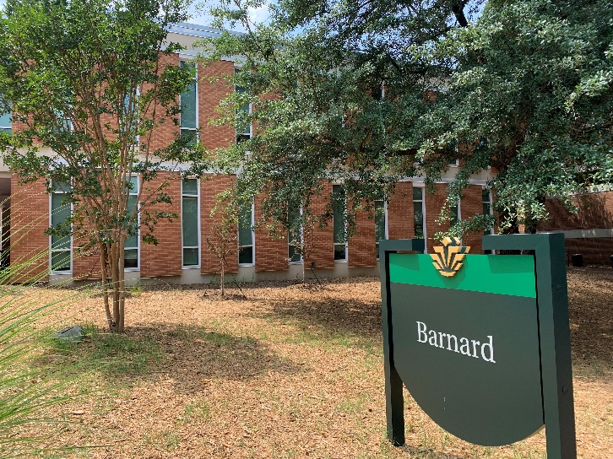

The Barnard building is one of the five buildings that make up the original quad of UNC Charlotte. Today, Barnard is home to the Department of Anthropology, Adult Students and Extended Services, and Veteran Student Services.

**Bioinformatics**

The Bioinformatics Research Center opened in 2009 as a teaching and research building on the campus of the Charlotte Research Institute. It is a multifunctional facility which fosters an interdisciplinary academic and entrepreneurial program. The center also support the nearby “Biopolis” (the North Carolina Research Center) through biotechnology efforts in plant genomics, health, and gene-related research.

The Bioinformatics Building is home to the Department of Bioinformatics and Genomics.

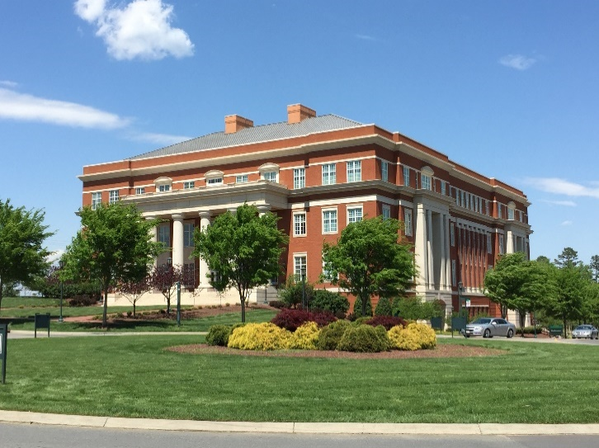

**Burson**

Sherman Burson Jr. was the first Charles Stone Professor of Chemistry and the inaugural dean of the-then College of Arts and Sciences.

A native of Pittsburgh, Pa., Burson was born Christmas Eve 1923. His father, a Methodist minister, moved the family to Massachusetts, where Burson graduated from Harwich High School. Uncertain of his career goals, Burson considered becoming a surgeon, psychologist or medical researcher.

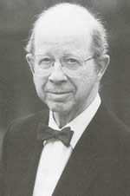With little money for college, Burson took the advice of his high school principal and moved South where college costs were lower. He spent the 1941-42 academic year at the University of Alabama. When money ran out, he returned to Pennsylvania, where he worked in a steel mill during the day and attended the University of Pittsburgh at night. World War II was under way, and Burson entered the U.S. Army. A special program enabled him to continue studies at Louisiana State University; following the war, he returned to the University of Pittsburgh, where he completed a bachelor’s degree in chemistry. He earned a doctorate in 1953.

In 1957, after nearly five years in private industry, Burson decided to pursue a career in academia. He joined the faculty of Pfeiffer College in Misenheimer. At the urging of Bonnie Cone, Burson accepted a position at Charlotte College in 1963. He was a professor of chemistry and chair of the department when Charlotte College became the fourth campus of the University of North Carolina in 1965. It was under Burson that the department achieved accreditation from the American Chemical Society.

UNC Charlotte’s first chancellor, Dean Colvard, appointed Burson acting dean of the College of Science and Mathematics in 1973, and in 1980, Chancellor E.K. Fretwell named him dean of the newly formed College of Arts and Sciences (now the College of Liberal Arts & Sciences), formed by the merger of the College of Science and Mathematics with the College Liberal Arts & Sciences. He held this post until retiring in June 1985.

Completed in summer 1985, the Sherman L. Burson Building was originally dedicated as the Physical Sciences Building. The 104,000-square-foot facility includes a 184-seat tiered lecture hall, a number of smaller lecture halls and laboratory space. Designed by Peterson Associates of Charlotte, the building was constructed by Butler and Sidbury Inc. for a little more than $8 million. At the time of its re-dedication in April 1999, the building was noted for its planetarium platform mounted on vibration-resistant pedestals, an underground Van de Graaf linear accelerator and reinforced concrete radiation labs.

The building’s design won a national architectural award and was included in the American School and Universities Architectural Portfolio for 1986.

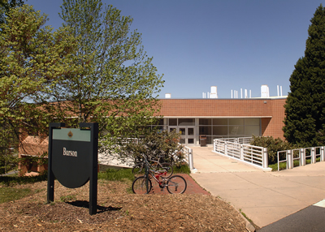

The Burson building’s innovative architecture includes an extremely complex mechanical system which ensures safe exhaust of poisonous and noxious fumes. Today, Burson is home to the Department of Chemistry, College of Computing & Informatics, and Physics and Optical Science.

**Cameron**

The C.C. Cameron Applied Research Center recognizes an individual whose civic and business leadership contributed to the development of UNC Charlotte and the entire UNC system.

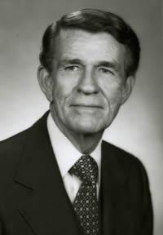Clifford Charles Cameron was born in Meridian, Miss. He later attended Louisiana State University, where he completed a bachelor’s degree in chemical engineering in 1941. Following service in World War II, he worked as an engineer for Standard Oil Co. At the urging of a war buddy, Cameron changed careers and became a mortgage banker in 1949. He entered this relatively new field with the creation of Cameron Mortgage Co. in Raleigh. The company merged with Brown-Hamel Mortgage Co. of Greensboro in 1955 and acquired the Carolina Realty Co. of Charlotte. This was the beginning of the Cameron-Brown Co. that would later combine with First Union.

Following that merger, Cameron moved to Charlotte, where he became chief executive officer of First Union in 1968. His affiliation with UNC Charlotte dates to 1967, when Cameron became a member of the board of directors of the UNC Charlotte Foundation. In the early 1980s, Cameron co-chaired UNC Charlotte’s first capital campaign and played a leadership role in the University’s Silver Anniversary Campaign. He also served as on the UNC Charlotte Board of Trustees and the UNC Board of Governors.

Through his involvement with the UNC Charlotte Foundation, Cameron is credited with helping to create University Place and the subsequent economic development that resulted. He also played a part in the development of the Ben Craig Center.

Chancellor emeritus E.K. Fretwell noted in a magazine article that “Cliff Cameron personifies corporate responsibility… He is giving of his management expertise, his leadership, his great prestige and his personal attention to assist the University of North Carolina at Charlotte in its quest for excellence.”

Before retiring as First Union chair in 1984, Cameron laid the groundwork for its growth as one of the nation’s top 20 banks. Committed to public service, Cameron served as an advisor to North Carolina governors for four decades. He was a member of Gov. Luther Hodge’s Business Development Corp., Gov. Dan Moore’s Council for Economic Development; Gov. Bob Scott’s Conservation and Development Board and Gov. Hunt’s Advisory Budget Commission and Transportation Study Commission. Under Gov. James Martin, Cameron served as an assistant for budget and management.

One of the University’s most prestigious scholarships bears the name of C.C. Cameron in recognition of First Union’s and his personal contributions that made the financial assistance possible. In honor of his service to the University and the state, UNC Charlotte awarded Cameron an honorary Doctor of Public Service in 1983.

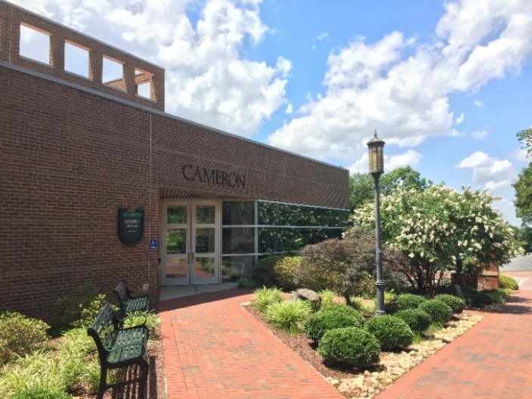

Completed in 1990 and dedicated on September 25, 1991, the Cameron Applied Research Center contained roughly 74,000 square feet of laboratory, office, and conference space to support world-class research. At the time, the center was the focal point for the University’s outreach mission to the region. It provided businesses, agencies and organizations access to academic and applied research expertise. A multipurpose facility, the center was designed for maximum flexibility to accommodate evolving research projects. It features clean-room and vibration-free spaces, a 96-seat auditorium and a media center equipped for teleconference and distance learning.

In 2000, the center was renovated and expanded to add roughly 42,000 square feet of space.

Today, the building is known as Cameron Hall and is home to the University Writing Program, Writing Resources Center, and Department of Systems Engineering and Engineering Management.

**Cato**

Dedicated May 6, 2004, Cato Hall is often the first point of contact for prospective students interested in enrolling at the state’s urban research institution. Named for Wayland H. Cato Jr., the building houses the Chancellor’s Office, Enrollment Management, Institutional Integrity, Office of Academic Affairs, and the Office of Assessment and Accreditation.

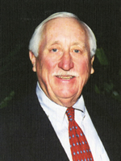A distinguished business leader and philanthropist, Cato was born in Ridge Spring, S.C., in 1923. His father, Wayland Cato Sr. worked for United Merchants and Manufacturers (UM&M), a New York-based textile conglomerate. The elder Cato moved his family to Augusta, Ga., in 1937, where the younger Cato attended the Academy of Richmond County, a compulsory ROTC military public school. He graduated with honors in 1940.

Cato Jr. enrolled at UNC-Chapel Hill and was elected to Beta Gamma Sigma, a national honorary scholastic commerce fraternity. He also joined the Naval Reserve Officers Training Corps. In 1944, Cato graduated in the top three percent of his class with a bachelor’s degree in commerce.

During World War II, he served nearly three years on active duty in the U.S. Navy, stationed aboard minesweepers in the Pacific Theatre.

Following his discharge, Cato joined his father and other family members in Charlotte. The elder Cato had left UM&M to start his own business, which became the Cato Corporation, a chain of women’s apparel stores. Cato Jr. became president and chief executive officer of the family business in 1960. He added the title chair of the board of directors in 1970. He retired as chair emeritus in 2004; his son John Cato was named CEO in 1999.

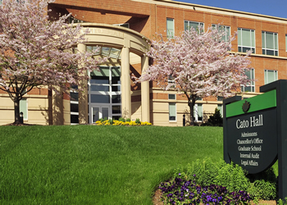

From 1995 to 2002, Cato Jr. was a director of the UNC Charlotte Foundation. Personally and corporately, he endowed a number of scholarship programs at the University. For his leadership in business in the Carolinas and service to the nation, state and community and for his commitment to learning and scholarship, Cato was awarded an honorary Doctor of Humane Letters during commencement in May 2002.

Conceived as the Humanities Office Wing, Cato Hall originally housed Undergraduate Admissions and the Graduate School, along with the Development Office and the departments of Communication Studies and Social Work. The three-story, 32,500-square-foot facility was built for $5.1 million using bonds approved by state voters in 2000 and other University funds.

**Colvard**

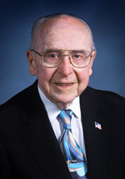The Colvard Building opened in 1979, and its steel-frame and curtain-wall construction and many energy saving features were considered progressive for its time. Harry Wolf of Wolf Associates designed the structure, and he won the 1980 South Atlantic Regional AIA Honor Award for his work. Among the energy-saving features Wolf utilized were vermiculite insulate roofing, insulated walls and a heat reclaimer. Also, the center arcade was designed for the horizontal and vertical movement of students in a space that did not need to be heated or cooled.

While many of Wolf’s design techniques are common today, 30 years ago they were considered forward-thinking. It is appropriate such a building honors Dean Wallace Colvard, UNC Charlotte’s first permanent chancellor, a man considered ahead of his time in many respects.

Born in 1913, Colvard was raised in the mountains of western North Carolina in Ashe County. President and salutatorian of his high school class, Colvard was the first member of his family to attend an institution of higher learning. He started at Berea College in 1931, where he earned a scholarship. He also met Martha Lampkin; they would wed in the college’s Danforth Chapel in 1939.

After completing his undergraduate degree, Colvard earned a master’s degree in endocrinology from the University of Missouri and a doctorate in agricultural economics from Purdue University. He also served as superintendent of North Carolina Agricultural Research Stations from 1938-46. In 1948, Colvard was hired to run North Carolina State University’s animal science program. Five years later, he became the dean of agriculture, a post he held until 1960, when he became president of Mississippi State University (MSU), where he unintentionally became part of college sports history. MSU had won three straight Southeastern Conference championships, but the institution declined to participate in the NCAA tournament rather than integrate, even briefly, on the basketball court. In 1963, Colvard defied a court injunction and allowed the MSU basketball team to compete in the tournament against a team with African-American players.

Colvard returned to his native state in 1966 after being named chancellor of UNC Charlotte. He embraced the challenge of turning a pioneering junior college into a university that had become the fourth member of the consolidated UNC system. As chancellor, he secured regional and national accreditation for University programs, helped create the University Research Park, added graduate programs, expanded the campus and oversaw the growth of the student body from 1,700 to 8,705 students.

He retired Dec. 31, 1978, but Colvard did not leave education behind. He helped build two other institutions: the School of Science and Mathematics at Durham and the hands-on museum Discovery Place. He died June 28, 2007.

Today, Colvard is home to the Departments of Communication Studies, Criminal Justice and Criminology, and Psychological Science; Organizational Science, School of Data Science, Office of Undergraduate Education, University Advising Center, University College, School of Professional Studies, Academic Diversity and Inclusion, and the University Center for Academic Excellence.

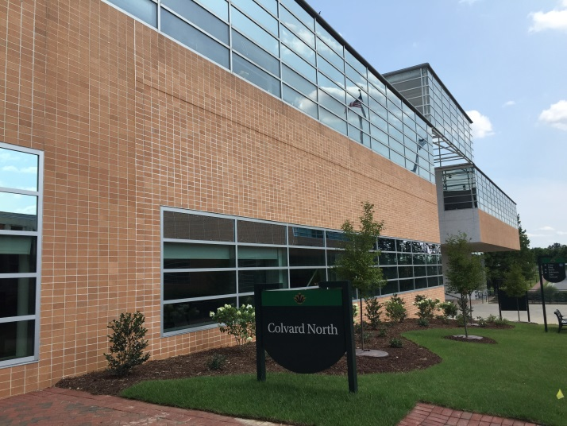

**Cone University Center**

Since first opening its doors in 1962, the Cone University Center has been a gathering place for students, faculty, staff, administrators, alumni and guests. As such, it is fitting that the facility bears the name of Bonnie Ethel Cone, the beloved mathematics teacher and visionary administrator who, perhaps more than anyone else, is credited as UNC Charlotte’s founder.

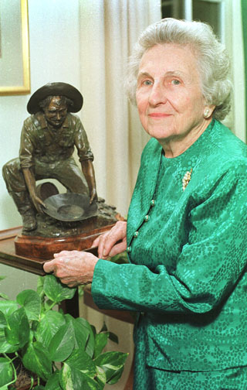Born June 22, 1907, in Lodge, S.C, “Miss Bonnie,” as she was affectionately called, taught high school in South Carolina for 12 years before moving to Charlotte's Central High School in 1940. During World War II, she taught math to men enrolled in the navy’s V12 program at Duke University, and she spent a year working as a statistical analyst for the Naval Ordnance Laboratory in Washington, D.C.

Cone’s background made her the perfect person to head one of the new extension centers established in the late 1940s to serve returning war veterans. Cone directed the Charlotte Center and signed on as a part-time instructor in engineering and math.

Always a firm believer that Charlotte needed a public university, Cone was determined to see one built in the Queen City. She helped turn the temporary veteran’s center into a permanent two-year college. In 1963, she played a key role in convincing the North Carolina General Assembly to make Charlotte College a part of the University of North Carolina system. On July 1, 1965, Bonnie Cone stood beside Gov. Dan Moore to ring the bell announcing the official creation of the University of North Carolina at Charlotte.

“Miss Cone has provided the faith on which the college many times found its primary ability to exist,” said J. Murrey Atkins in a tribute. “She has stuck with it and never even thought of giving up when sometimes the sledding seemed pretty hard.”

Cone served as acting chancellor for nine months and remained committed and loyal to UNC Charlotte. She served as vice chancellor for student affairs and community relations until she retired in 1973. On June 29, as part of her retirement service, the UNC Charlotte Board of Trustees named the University Center in her honor. In retirement, Cone continued to raise money and support the University until her death in 2003.

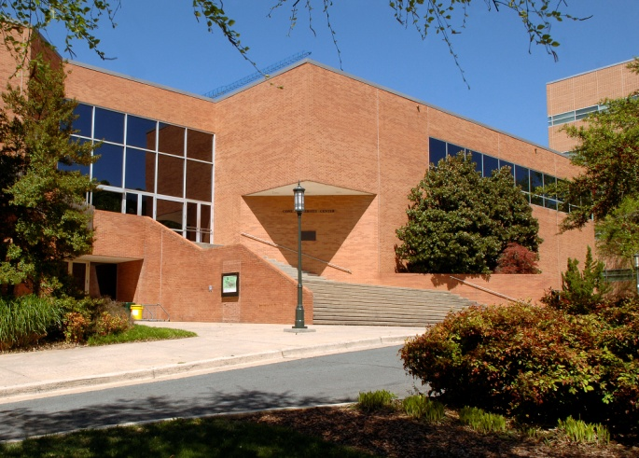

Today, Cone is home to Niner Central, Center for Graduate Life, University Scholarship Office, Office of Fraternity and Sorority Life, Diversity & Inclusion, Cone Center Conferences, College of Computing & Informatics, and Main Street Market.

**Denny**

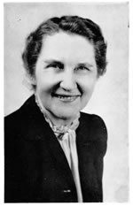In 1965, a new campus facility designed by Odell Associates was completed at a cost of $569,000. Five years later, the building was dedicated in honor of Mary Rebecca Denny, chair of the UNC Charlotte English Department for 14 years.

Denny was born on Aug. 12, 1896, on the family farm near the small town of Red Springs, N.C. She attended Salem College and taught English in several public schools in eastern North Carolina after completing her bachelor’s degree in 1917. She went on to earn a master’s degree from Duke University and become associate professor of English at Queens College. She left Queens in 1946 to become the first full-time faculty member at the Charlotte Center of the University of North Carolina (now UNC Charlotte).

Although the Charlotte Center was created to serve in an emergency situation, Denny believed that it would eventually provide more than a temporary opportunity for its students. She was right as the Charlotte Center became Charlotte College, one of the first two-year community colleges in North Carolina, in 1949.

During the next 15 years, Denny completed an impressive list of initiatives, including the creation of the college newspaper, the literary magazine and the college catalog. When Charlotte College became a four-year institution, Denny relinquished her role as department head, but she remained active with the Curriculum Committee. She retired in 1964, with the distinction of being the institution’s first professor emeritus.

At the October 9, 1970, dedication ceremony naming what was then the largest classroom building in her honor, UNC Charlotte trustees enthusiastically paid tribute - “We transform glass, steel and stone into a monument to your spirit – forthright, steadfast, energetic and humanitarian. May this building forever serve as a reminder of your commitment to the ideals of sound scholarship, integrity and excellence.”

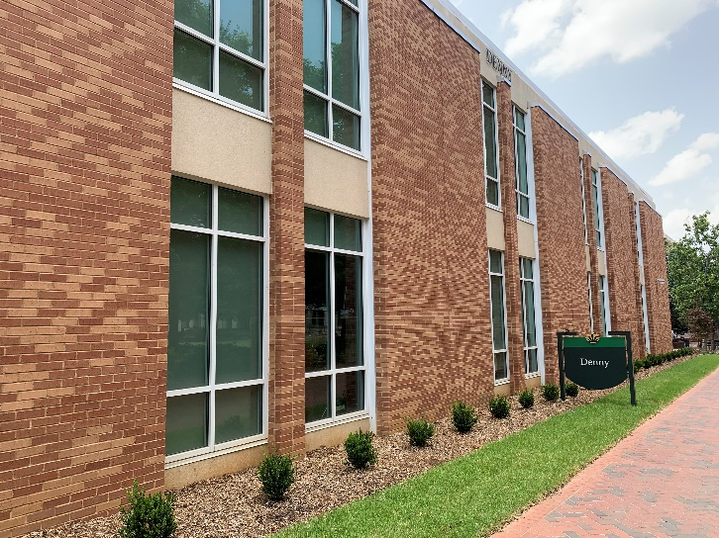

Following her retirement, Denny returned to her family home in Red Springs, where she resided until her death in 1979.

The Denny building is one of the five buildings that make up the original quad of UNC Charlotte.

**Dubois**

With the retirement of UNC Charlotte’s fourth chancellor in 2020, the University’s Center City Building was renamed The Dubois Center at UNC Charlotte Center City (The Dubois Center) to recognize Chancellor Philip L. Dubois and First Lady Lisa Lewis Dubois. The building is regarded as a centerpiece to Dubois’ 15-year term as chancellor.

Dubois’ career in higher education spans more than 40 years. As a first-generation college student, he earned a bachelor’s degree in political science in 1972 from the University of California, Davis, and a master’s (1974) and doctoral (1978) degree in political science from the University of Wisconsin-Madison. Dubois returned to the University of California, Davis, to start his career in academia as an assistant professor, rising through faculty and administrative ranks to hold various positions, including full professor and associate vice chancellor for academic programs.

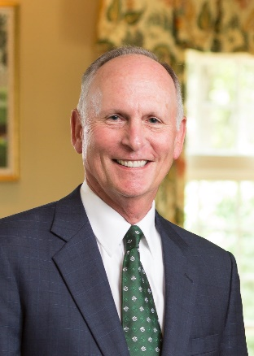In 1991, Dubois was recruited to UNC Charlotte, where he spent five and a half years as provost and vice chancellor for academic affairs. Under his leadership, UNC Charlotte planned and implemented its first doctoral programs. He led the creation of a strategic academic plan, which included creating programs to reach more nontraditional students, recognizing that as an important goal for an institution founded to educate veterans.

In 1997, Dubois left UNC Charlotte to become president of the University of Wyoming, where he led the development and implementation of comprehensive academic, support services and capital construction plans, expanded the University’s role in statewide economic development, and improved student recruitment and retention.

In 2005, Dubois returned to UNC Charlotte and was named chancellor. During his 15-year tenure, he led the University through a 43% growth in enrollment, an expansion of academic programs, the implementation of diversity-related initiatives, growth in research funding and the construction and renovation of campus facilities. He increased the University’s visibility in the Charlotte region and beyond, with undergraduate enrollment reaching nearly 30,000 under his leadership, led the largest facility construction and renovation program in UNC Charlotte’s history, and under Dubois’ strategic direction, football was added to the University’s athletics offerings in 2013.

Dubois collaborated with elected officials and the Charlotte Area Transit System to make possible the construction of the light rail line from Center City Charlotte to the UNC Charlotte campus, increasing the connection and opportunities for partnership between the University and the rest of the city. He oversaw the implementation of new academic degree programs — 10 bachelor’s, 17 master’s, and 12 doctoral — and established or helped in the development of new offices to support students. To reach more non-traditional students, Dubois implemented the award-winning 49er Finish program, which helps students who left the University to complete their degrees, and partnered with Central Piedmont Community College to launch the 49erNext program, which creates a clear path for community college students to enroll at UNC Charlotte. Dubois worked with Charlotte Mecklenburg Schools to create two early colleges at UNC Charlotte, one for students interested in STEM fields and another for those interested in teaching.

The Dubois Center opened in Fall 2011 and is the only University of North Carolina classroom building conceived and designed specifically to serve the business, organizations, and people of an urban center. Its 25 state-of-the-art classrooms and design studios accommodate more than 1,500 students annually who earn bachelor’s or master’s degrees in business, architecture, urban design, education, public administration or health administration, plus about 2,600 more who participate in certificate and other continuing education options. In addition, The Projective Eye Gallery, located near the lobby, regularly exhibits the work of artists known locally, nationally and internationally.

The Dubois Center hosts over 2,000 meetings and events annually and includes both university and community constituents.

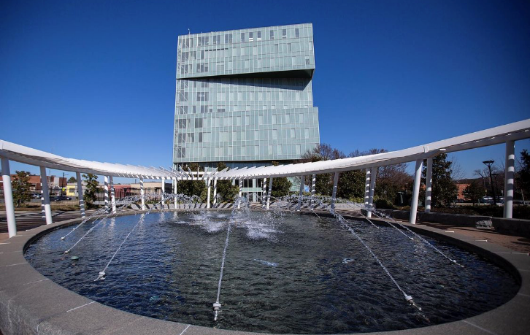

**Duke Centennial**

Duke Centennial Hall was dedicated on September 8, 2006, in honor of Duke Energy’s century of service and its commitment to leadership for the future.

Duke Energy’s history in the Carolinas dates back to 1904, when its first power station was built on the Catawba River. Cheap hydroelectric power helped transform the regional economy from agriculture to manufacturing.

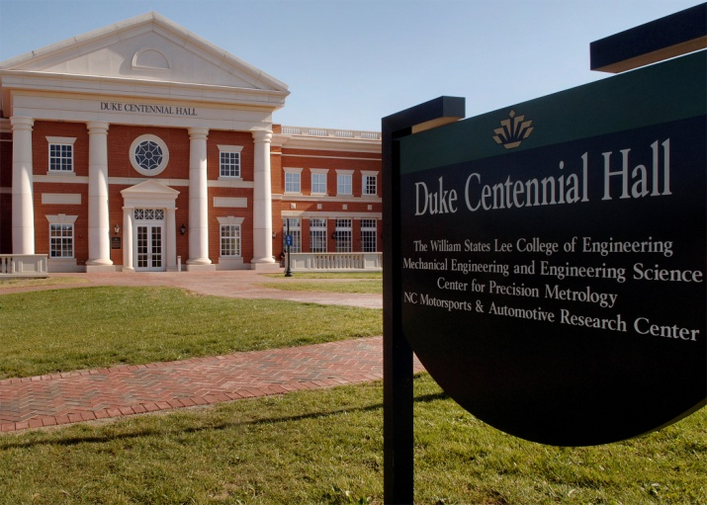

In the 21st Century, our economy continues to change. Duke Energy partnered with UNC Charlotte to help establish the Charlotte Research Institute to advance technology, foster innovation, and drive economic growth in our region.

Duke Centennial is home to the College of Engineering, Mosaic Lab, Center for Precision Metrology, and the Department of Mechanical Engineering and Engineering Science.

**Fretwell**

The E.K. and Dorrie Fretwell Building honors the campus contributions of UNC Charlotte’s second chancellor and his wife.

At the time of its dedication on May 23, 1996, the 162,000-square-foot facility was the largest academic structure on campus. It contains approximately 250 faculty offices and classroom seating for about 2,100 students. Built for $18 million, the four-story facility was constructed with revenues from a bond issue approved by North Carolina voters in a November 1993 referendum.

The son of two teachers, E.K. Fretwell was born in New York City. He earned a bachelor’s degree at Wesleyan University, a master’s in teaching from Harvard University and a doctorate from Columbia University. An Associated Press correspondent, writer for the American Red Cross, vice consul for the American Embassy in Prague and middle and high school teacher, Fretwell entered education administration in 1956 as assistant commissioner for higher education for the New York State Board of Regents. He also served as dean for academic development at the City University of New York and president of the State University of New York College at Buffalo. In addition, he was president of the American Association for Higher Education and chair of the Carnegie Foundation for the Advancement of Teaching.

A national leader in education, Fretwell became UNC Charlotte’s second chancellor in January 1979. At the time, the University’s enrollment was around 8,700 students. By his retirement in June 1989, UNC Charlotte’s enrollment topped 13,000.

During his tenure, Fretwell merged the College of Humanities, Social, and Behavioral Sciences and College of Science and Mathematics into the College of Arts and Sciences (now the College of Liberal Arts & Sciences) and created the Graduate School. Besides enhancing UNC Charlotte’s national reputation for educational excellence, Fretwell increased the institution’s links to the community through the expansion of the Urban Institute and University Research Park, the development of University Place and establishment of the C.C. Cameron Applied Research Center.

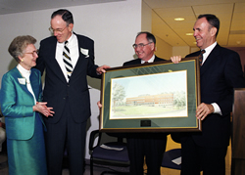

Chancellor Emeritus Fretwell (second left) with his wife Dorrie at the formal dedication ceremony for the Fretwell Building

Throughout his career, Fretwell relied upon his wife Dorrie; he was quoted often as saying they were a team. Born in Chicago, Dorrie Shearer Fretwell grew up in Evanston, Ill. She earned bachelor’s and master’s degrees in applied music at Drake University. Before her marriage, Fretwell studied voice at the American School of Music in Fontainebleau, France, and began her career as a professional soprano, performing as a soloist with choral societies, musical clubs and opera productions on stage and television. During her husband’s tenure in Buffalo, Fretwell served as vice chair of the board of the Buffalo Philharmonic Orchestra and vice president of the Girl Scouts. In Charlotte, she was on the board of Opera Carolina and the Charlotte Symphony. Among the initial enrollees of UNC Charlotte’s graduate program in clinical psychology, she was its first graduate. She went into practice with Carolina Psychological Services and published a number of articles related to depression and headache management before retiring in 1996. She passed away December 30, 2011.

At the University’s formal ceremony to dedicate the E.K. and Dorrie Fretwell Building, Allan Ostar, president emeritus of the American Association of State Colleges and Universities, noted “as a magnificent center of learning, it is a fitting tribute to a towering educational leader.”

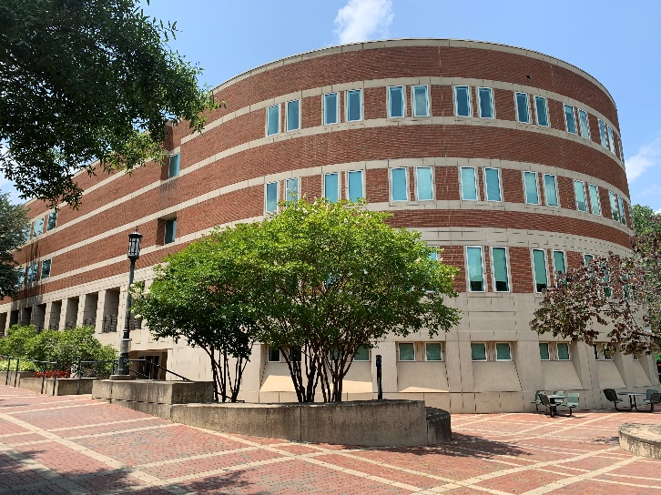

Today, Fretwell is home to the College of Liberal Arts & Sciences; Departments of English, Mathematics and Statistics, Political Science and Public Administration, and Sociology; American Studies, Liberal Studies, Women’s and Gender Studies programs, Political Science & Public Administration, Interdisciplinary Studies, and Disability Services.

**Friday**

The Ida and William Friday Building houses the Belk College of Business, and it honors the many contributions of William C. Friday to the University of North Carolina system.

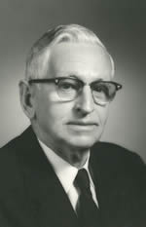Born in Raphine, Va., Friday grew up in the Gaston County town of Dallas, where he played baseball and basketball. He attended N.C. State University, graduating with a bachelor’s degree in textile manufacturing. As a senior, Friday met Ida Howell from Lumberton who was pursuing a bachelor’s degree in home economics at Meredith College. They married on May 13, 1942, and Bill Friday continued his education at UNC-Chapel Hill where he earned a law degree. Ida Friday also furthered her studies, obtaining a master’s in public health from UNC-Chapel Hill.

Friday spent the majority of his career in higher education. He was assistant dean of students at UNC-Chapel Hill, assistant to the president of the Consolidated University of North Carolina and secretary of the University of North Carolina. At age 36, Friday was named acting president of the UNC system. He would lead the system until 1986. During his tenure, he became recognized as one of America’s most respected and effective educational leaders. Through the 1963 Higher Education Act, Friday redefined the purpose of each institution of the UNC system (at the time, UNC-Chapel Hill, N.C. State University and UNC Greensboro; UNC Charlotte become the fourth member of the system in 1965). In 1972, he reorganized the entire system which had grown to include 16 campuses (now 17 after the addition of the N.C. School of Science and Mathematics).

On more than one occasion, Friday noted his achievements could not have been possible without his wife, Ida. He said, “It took two of us to do this.” As “first lady” of the UNC System, Ida Friday was active in community service, including president of the Chapel Hill Preservation Society, member of the board of the North Carolina Symphony Society, chair of the YMCA and YWCA at UNC-Chapel Hill and a member of the League of Women Voters.

Dedicated in 1982, the Friday Building incorporated the best classroom designs for teaching future business leaders for its time. UNC Charlotte faculty and staff, along with the architect, visited a number of institutions recognized for having leading business programs, including Harvard University, the University of Virginia and the University of Tennessee.  The Friday Building’s classrooms are modeled after the case classrooms pioneered at the Harvard Graduate School of Business.

The 64,000-square-foot building was designed to accommodate a third floor, which was constructed in 1994-95 using $3 million from a state bond referendum approved by voters in 1993. Changes in the building code required the University to make the facility more earthquake resistant. The columns that grace Friday Building contribute to its distinctive look; they were added during the expansion at the suggestion of Chancellor Emeritus Jim Woodward.

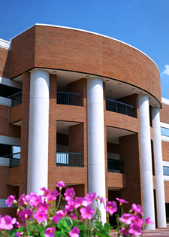

Several other UNC institutions have honored the Fridays with buildings on their campuses, including N.C. State University (the William and Ida Friday Institute for Educational Innovation), UNC-Chapel Hill (the William and Ida Friday Center for Continuing Education) and UNC Wilmington (Friday Hall).

Today, Friday is home to the Belk College of Business and its academic departments and programs.

**Gage**

The Gage Undergraduate Admissions Center opened for the Fall 2019 semester. The two-story, 18,000-square-foot building welcomes prospective students and their families to campus. Additionally, the Center is home to the Office of Undergraduate Admissions and serves as the starting point for campus tours. This facility was made possible through an estate gift by the late Dr. Lucius G. Gage, Jr.

Dr. Gage was a Charlotte physician and a major benefactor to UNC Charlotte. He passed away in September 2011. He was educated in the Charlotte city schools and entered Duke University for his undergraduate degree after his junior year in high school. He then went on to Duke Medical School where he was recognized for exemplary performance. He completed his residency at the University of Virginia. Gage returned to Charlotte to practice medicine at the Nalle Clinic with his father, the late Dr. Lucius G. Gage, Sr., a founding partner, assuming the Director position in the Allergy and Arthritis Department.

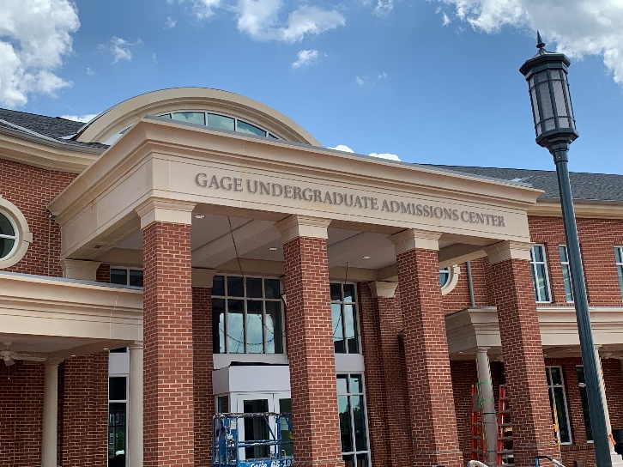

**Garinger**

Elmer Henry Garinger was one of the visionary leaders who helped Charlotte College realize the dream of becoming a four-year, state-supported institution.

As superintendent of Charlotte City Schools, Garinger employed Bonnie Cone, UNC Charlotte founder, as a mathematics teacher at Central High School. Later, he would name her director of the Charlotte Center of the University of North Carolina, the institution that ultimately became UNC Charlotte.

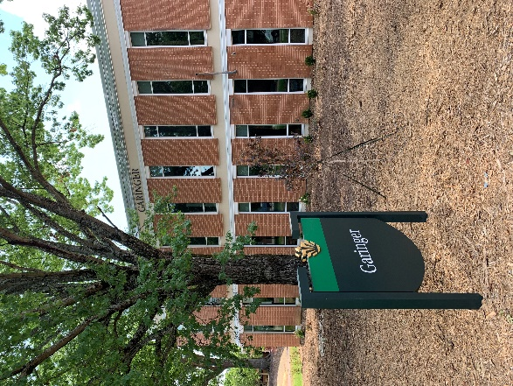Born July 13, 1891, in Mount Vernon, Mo., Garinger graduated from the local high school and continued his education at the University of Missouri. He completed a bachelor’s degree in 1916, and eventually, he earned a master’s degree and doctorate from Columbia University.

During his 40-year career with Charlotte City Schools that began in 1921, Garinger gained a national reputation as a leader in education. In 1949, he was named superintendent of Charlotte City Schools, and he took the lead in planning for the consolidation of the Charlotte and Mecklenburg County school systems, a goal achieved in 1959. Garinger served for a year as superintendent of the new system, retiring as superintendent emeritus.

Garinger’s association with UNC Charlotte continued throughout his life. He was instrumental in requesting the Charlotte Center be founded, and he was among the Charlotte leaders who worked to change the Charlotte Center to Charlotte College in 1949. When the institution was placed under the community college system in 1958, Garinger was named secretary of the first Board of Trustees of the Charlotte Community College System; he served in this capacity until 1963, when Charlotte College became a four-year, state-supported institution.

After retiring from the Charlotte-Mecklenburg Schools, Garinger worked to improve public education as a member of the N.C. House of Representatives, where he served two terms. In honor of Garinger’s service to public education and the University, UNC Charlotte’s Board of Trustees voted to name the first faculty building, constructed in 1965, in his honor. The Elmer Henry Garinger Building was dedicated in October 1970; a portrait of Garinger that hangs in the building was dedicated in March 1987.

He died in Charlotte on August 21, 1982.

The Garinger building is one of the five buildings that make up the original quad of UNC Charlotte. Today, Garinger is home to the Departments of Africana Studies, Philosophy and History.

**Grigg**

Dedicated on Sept. 8, 2006, William H. Grigg Hall is home to a number of Charlotte Research Institute offices and facilities, including the Center for Optoelectronics and Optical Communications.

Named for the chair emeritus of Duke Energy, Grigg Hall is a 96,820-square-foot, state-of-the-art academic and research facility. In 2002, the Duke Energy Foundation announced a $10 million gift to the University’s capital campaign in support of Charlotte Research Institute programs and initiatives. Construction of Grigg Hall began in 2003 with funding from the state’s $3.1 billion bond referendum approved by North Carolina voters in 2000.

Grigg, who grew up in Albemarle, completed a bachelor’s degree from Duke University in 1954. After serving two years in the U.S. Marine Corps, he earned a law degree with distinction from Duke in 1958. After practicing law in Charlotte for five years, Grigg joined Duke Power in 1963 as assistant general counsel. He was promoted to vice president of finance in 1970 and vice president and general counsel in 1971. Elected to Duke Power’s board of directors in 1972, Grigg eventually was named vice chair in 1991 and chair and chief executive officer in 1994. He retired in 1997.

During Grigg’s tenure with Duke Power, he guided the corporation through some of the most challenging times in the electric utility industry. He helped expand and diversify the company’s power plants and led the company’s response to competition, including the merger with PanEnergy in 1997 to create Duke Energy. Grigg was named Electric Utility CEO of the Year for 1995 by Financial World magazine.

Committed to civic leadership and quality education, Grigg has served countless community groups, including the Charlotte-Mecklenburg Hospital Authority, Foundation for the Carolinas and the Lynwood Foundation. In honor of his contributions to Charlotte and the greater community, UNC Charlotte awarded Grigg an honorary doctorate of public service in December 1997.

The architectural firm of Perkins-Will, which has offices nationwide, designed Grigg Hall. Constructed for roughly $24 million, Grigg Hall features a 3,000-square-foot clean room, a controlled environmental space used for research and manufacturing. Clean, contamination-free rooms are used in a variety of research settings – electronics and optics, as well as pharmaceuticals and DVD manufacturing.

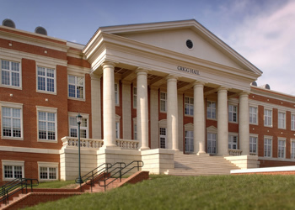

Today, Grigg is home to the Department of Physics and Optical Science, Optoelectronics Center, Electrical & Computer Engineering, and Charlotte Research Institute.

**Johnson**

The Vickie and Gene Johnson Marching Band Center is home to the UNC Charlotte “Pride of Niner Nation” Marching Band.

The 6,700 square foot building houses a conference room, music library and four offices for the band staff. It also includes a storage room for drumline and colorguard equipment, as well as ample space to store musical instruments and uniforms for the entire marching band. The band began performing in Fall 2015 with 145 members, but will eventually grow to include 300-350 members.

Johnson Band Center (JBC) was designed by the award-winning architecture firm Watson Tate Savory. The design reflects the architectural characteristics of Storrs Hall and Robinson Hall, and the building serves as an architectural landmark for patrons going to and from events in the College of Arts + Architecture.

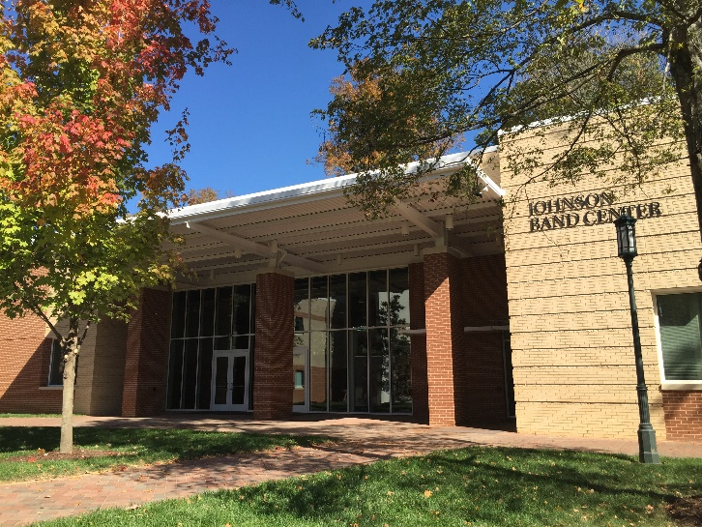

Johnson Band Center is one of a few buildings in the nation dedicated exclusively to a marching band.

**Kennedy**

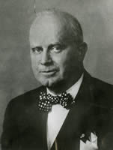The W.A. Kennedy Building was one of the first two facilities on campus. Designed by A. G. Odell Jr., the architect of Ovens Auditorium and Bojangles Coliseum, the building was named for Woodford A. “Woody” Kennedy. Sometimes called the “spiritual father of Charlotte College,” Kennedy was a member of the first advisory board of the institution in 1947. He was named to its eight-member board two years later. Without Kennedy’s perseverance, Charlotte College likely would have remained a two-year community college.

Kennedy believed that Charlotte deserved and needed a great university. He stated that a thousand additional high school graduates could go to college each year if the opportunities available in other parts of the state were available in Charlotte. With a zeal he once termed an obsession, Kennedy worked tirelessly to raise money and support to make that happen.

He encountered a lack of support among many of Charlotte’s business executives and disinterest from politicians. His rhetoric sometimes became strident, characterizing critics of the project as naysayers and deriding the state’s support as a ‘sop.’

At the time, the school operated with a part-time faculty who taught in part-time classrooms, and it was financed almost entirely by tuition paid by student loans until Kennedy pushed for and obtained the initial state funding in 1955.

As a member of the college’s site selection committee, he searched for a scenic location with room for growth and expansion; the committee ultimately settled on the present location of the UNC Charlotte campus. He told reporters, “I may not but you will live to see 10,000 students at Charlotte College.”

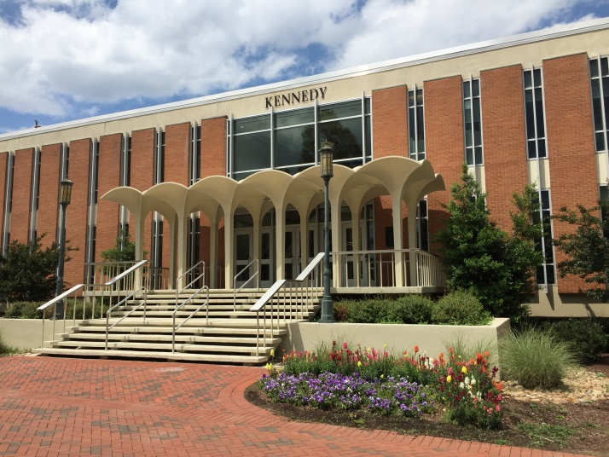

The statement proved prophetic. Kennedy died on May 11, 1958, the eve of his installation as a trustee of Charlotte Community College. But his contribution was not forgotten. The trustees proposed that the first building on the new campus be named for him. The building was dedicated on Feb. 16, 1962.

When Kennedy Building first opened, it housed science laboratories (chemistry, physics, biology and geology), as well as labs for a variety of engineering courses. There were 10 classrooms, 12 faculty offices and a lecture room with elevated seating for 100. The building also served as a temporary library; its first floor contained 18,000 volumes while Atkins Library was being built.

Today, Kennedy houses the SPS Course Production and Faculty Development and One IT.

**King**

Arnold K. King may be one of the few individuals to have a building named in his honor on two UNC system campuses. Ten years before UNC Charlotte dedicated the King Building for him, UNC Wilmington put King’s name on an administrative and classroom building. Such an honor is an indication of the vital role King played throughout the UNC system.

From his days as a student at UNC-Chapel Hill in the 1920s until his retirement as special assistant to UNC President William Friday, King was an integral part in the development of the University of North Carolina system. After receiving his bachelor’s degree, he continued his education at the University of Chicago, completing a master’s and doctorate. Returning to Chapel Hill, King served as a professor, graduate school administrator, head of summer sessions and vice president. He also was as acting chancellor for UNC Asheville in 1977.

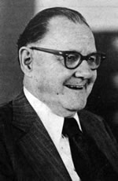King participated in a number of education-related study commissions, panels and boards across North Carolina and around the country. UNC President Friday and King were colleagues for more than 20 years. The UNC leader turned to King for his assessment when planning for the system’s future. King served as a liaison between Friday and Charlotte College during the institution’s transition to becoming the University of North Carolina at Charlotte. He later played the same role for UNC Asheville and UNC Wilmington.

In addition to his long service to the UNC system, King was one of the founders of N.C. Wesleyan College, and he was considered an expert on the history of the UNC system. In retirement, he wrote “The Multi-campus University of North Carolina Comes of Age: 1956-1986,” a historical bibliography of his three decades working in the system. He finished a 20-page manuscript on UNC’s University Day celebration just two days before his death.

The architectural firm of Odell Associates Inc. designed the building, which was constructed by F.N. Thompson Inc. in 1966 at a cost of $603,000. The King Building was originally named for Addison Hardcastle Reese. It was renamed for King following the dedication of Reese Building, which opened in 1982. Dr. King passed away on March 31, 1992, at the age of 90. A resolution in his memory noted, “Our University lost a part of its memory and conscience, and it lost a great friend.”

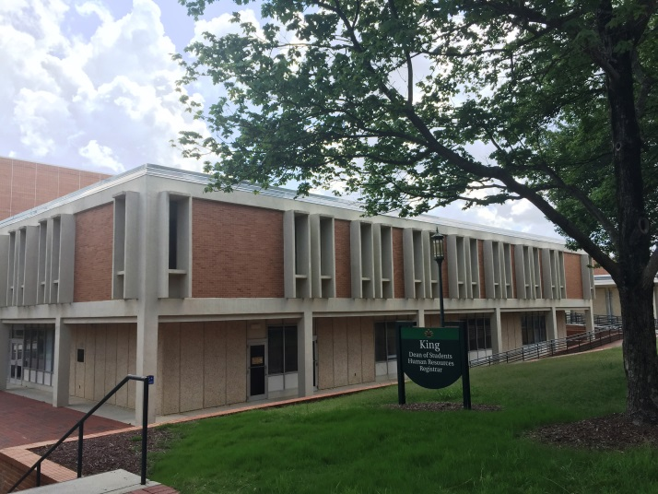

Today, King is home to the Dean of Students Office, Human Resources, Office of the Registrar, and Student Affairs.

**Macy**

The Macy Building was one of the first two facilities constructed on the UNC Charlotte campus. It was named for Pierre Macy, professor of French and chair of the-then Foreign Language Department. The 18,000-square-foot research and instructional facility was constructed concurrently with the Kennedy Building by Odell Associates in 1961 at a cost of $418,000.

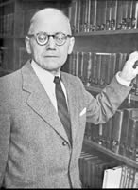Macy was born in France in 1899 and received degrees from the University of Nancy, the University of Dijon, and the University of Paris before making the United States his adopted home.

The noted author and translator arrived at Charlotte College in 1949 and almost single-handedly established and maintained the fledgling college’s Foreign Language Department (now the Department of Languages and Culture Studies). Before joining the faculty of Charlotte College, Macy was chair of the Romance Language departments at Kentucky Wesleyan College, the University of Tulsa and the College of William and Mary. He returned to his alma mater, the University of Nancy, for one year as a visiting professor.

An integral faculty member of the college, Macy served on the curriculum committee, chaired the concerts and lectures committee, advised the French Club and later served on the University’s executive committee.

Students held Macy in such high regard that the 10th edition of the yearbook was dedicated to him in 1960 “for his deep understanding, patient guidance and personal interest in the students of Charlotte College. He has inspired us to greater achievements through his teaching and counseling, and he will be fondly remembered in our memories of Charlotte College.”

Macy served as the first commencement marshal for the newly established University. His dedication to UNC Charlotte went well beyond any specific position he held. He taught French three years after relinquishing the department chairmanship and stayed on the faculty two years after he reached retirement age.

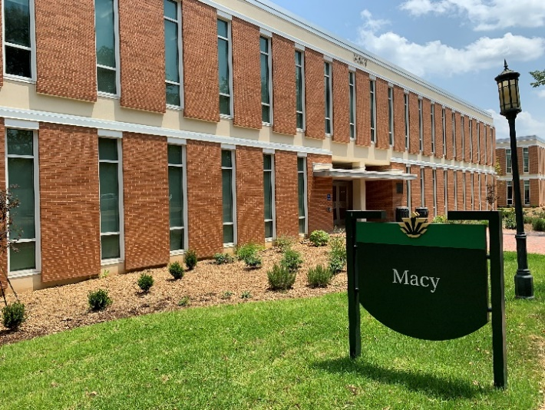

At his 1969 retirement, he received the rare honor of being named a faculty emeritus from his colleagues. “The Foreign Language Department, carefully constructed by Dr. Macy over the years was clearly one of the solid blocks of the foundation of the new institution,” read the tribute. He is further remembered today with the Pierre Macy Award for Excellence in French.

The Macy building is one of the five buildings that make up the original quad of UNC Charlotte. Today, Macy is home to the Department of Global Studies and Department of Religious Studies, Art & Art History, and the College of Arts & Architecture.

**McEniry**

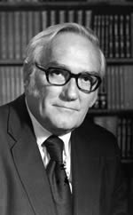Built to house the University’s earth and life sciences programs, the McEniry Building is named for UNC Charlotte’s first vice chancellor for academic affairs, William Hugh McEniry. The $4 million, 103,000-square-foot facility was completed July 7, 1975, to house the Departments of Geography and Earth Science and Biology.

Chancellor Dean Colvard hired McEniry (pronounced My-Canary) in 1967; Colvard was searching for a top-notch administrator with an arts and sciences background. Based upon numerous recommendations, Colvard recruited McEniry away from Stetson University where he had spent 27 years and served as a university dean. Ready for a new challenge, McEniry and his wife, Mary, relocated to North Carolina and settled into a 17-acre plot of land between the University and Huntersville they dubbed “Rural Simplicity.”

McEniry is credited with recruiting dedicated and talented faculty to UNC Charlotte, and he was active in a number of organizations, such as the North Carolina Association of Colleges and Universities and the College Entrance Board. He also served as president of the Southern Association of Colleges and Schools.

Dedicated to improving higher education for blacks, McEniry served as a trustee of Johnson C. Smith University. In addition, he personally financed scholarships for some black students and worked with the Ford Foundation to improve academics and the curricula for historically black colleges.

In 1973, McEniry agreed to serve as acting chancellor at Western Carolina University in Cullowhee until a permanent chancellor was hired. He passed away on March 15, 1974, at the age of 57.

The McEniry Building is just one lasting tribute to the University’s pioneering vice chancellor. Each year, a member of the graduating class with the highest GPA receives the W. Hugh McEniry Award for Academic Excellence. The North Carolina Association of Colleges and Universities named its top honor for the trailblazing educator - the Hugh McEniry Award for Outstanding Service to North Carolina Higher Education. Following McEniry’s death, Stetson University established the McEniry Award, a prestigious honor given a professor as selected by faculty members and students.

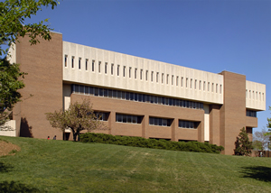

Today, McEniry is still home to the Department of Geography and Earth Sciences.

**Memorial Hall**

Memorial Hall is dedicated to fallen U.S. veterans. The building houses the Departments of Military Science (Army ROTC) and Aerospace Studies (Air Force ROTC). It serves as a memorial to commemorate UNC Charlotte students who have served in any branch of the Armed Services and lost their lives in service to the country.

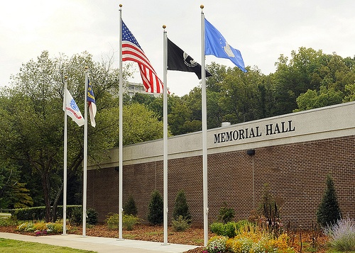

**Popp Martin Student Union**

The UNC Charlotte Student Union originally opened its doors in 2009 as the community center of the University. On any campus, the union serves students, faculty, staff, alumni, and visitors. It provides services and conveniences that members of the college community need in their daily lives and creates an environment for getting to know and understand others through formal and informal associations. It was renamed the Karen A. Popp and Demond T. Martin Student Union in 2016 to honor the dedication and service of two extraordinary alumni, Karen Popp ('80) and Demond Martin ('97).

Karen A. Popp was born in North Carolina, but moved often because of her father’s successful career as a high school, college, and NFL football coach. Karen graduated cum laude from UNC Charlotte in 1980, then attended Oxford University in England on a Rotary International Scholarship where she studied law and rowed for her college. She then attended law school at UNC Chapel Hill, serving as an editor on the North Carolina Law Review, becoming a member of the Order of the Coif and graduating cum laude. She has had an exemplary career as an attorney in private practice and the government. Karen clerked for the Honorable Sam J. Ervin, III of the U.S. Court of Appeals for the Fourth Circuit, moved to New York City where she was a Wall Street lawyer at Sullivan & Cromwell, and then an Assistant U.S. Attorney in the Eastern District of New York. She moved to Washington, D.C. to serve in the Office of Legal Counsel at the U.S. Department of Justice, as Associate White House Counsel for President Bill Clinton and as a partner in the international law firm of Sidley Austin, where she led the White Collar corporate defense practice and was a member of the firm’s Executive Committee. Karen has received numerous professional awards, honors, and recognitions for being one of the best lawyers in the world and a trailblazer for women.

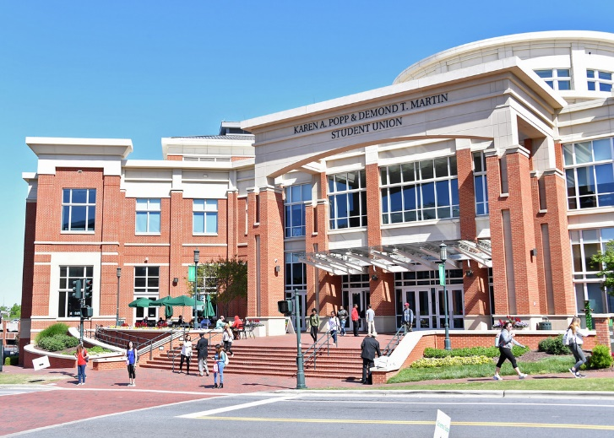

Demond Martin spent his childhood in Columbus, Ohio, and Inglewood, California; but spent many of his most formative years in Mocksville, North Carolina. Demond was thrilled to be admitted into UNC Charlotte, and immediately felt at home from his first visit. Coming from a small town, he fell in love with the campus and reveled in the opportunity to interact with students from such varied backgrounds. He took part in many campus activities, but it was his participation in the University Transitions Opportunity Program (UTOP) that introduced him to Dr. Herman Thomas, who became a lifelong mentor and challenged Demond to become a person of consequence — not for its own sake, but to best position himself to serve others.

In part due to the UTOP experience, Demond came to campus with a sense of who he wanted to become, and was involved in leadership activities from the moment he arrived. He became SGA president as a sophomore — an unprecedented event at UNC Charlotte at the time. He also joined Alpha Phi Alpha fraternity, Mu Tau chapter and would serve as chapter president. In honor of his skill as an orator, the Chapter established the annual Demond T. Martin Oratorical contest. He would go on to win numerous awards and distinctions, but one of his most gratifying experiences was to be part of a group of student leaders who escorted Ms. Rosa Parks through the city of Charlotte to address students and to inspire a call to action. Demond received his Bachelor of Science degree in Accounting in 1997, having left a mark on the campus, both students and faculty alike.

**PORTAL**

The Partnership, Outreach, and Research to Accelerate Learning (PORTAL) building, which opened in February 2014, demonstrates UNC Charlotte’s commitment to foster partnerships with private industry. Designed to stimulate business growth and job creation along with promoting research and innovation and supporting the entrepreneurial ecosystem of the Charlotte region, PORTAL is a venue where entrepreneurs can collaborate with peers, faculty members, and students to harness the power of a research university to plan strategies that lead to business success.

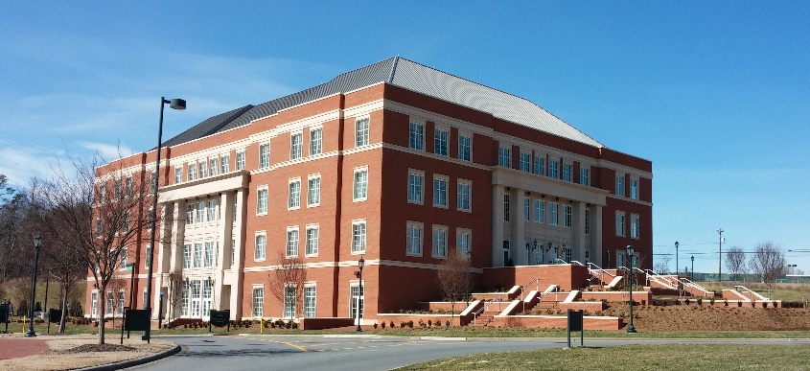

PORTAL is outfitted with over 90,000 square feet of floor space dedicated to business innovation and partnership with front door access to the exceptional resources, facilities, and academic talent found on the UNC Charlotte campus. The building has a contemporary aesthetic and 4-story atrium bound by office suites, meeting rooms, and a café. Business tenant offices and suites start at about 200 square feet and are expandable as required. An abundance of naturally lit community gathering spaces – including glass enclosed meeting rooms located on two atrium transecting bridges – facilitate networking and idea exchange. Business tenants have access to any of PORTAL’s four meeting rooms on a scheduled basis.

**Reese**

Around Charlotte, Addison Hardcastle Reese is probably better known as a titan of the banking industry rather than for his passionate commitment to UNC Charlotte.

Born in Baltimore County, Md., on Dec.28, 1908, Reese attended Johns Hopkins University but left after his junior year to begin his lifelong career in banking. He worked as a clerk, a senior national bank examiner and a bank vice president all before serving in the U.S. Air Force during World War II.

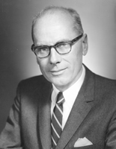Reese returned to banking after the war and was recruited to Charlotte in 1951 as executive vice president of American Trust Company. He was promoted to president in 1954 and organized a series of mergers that became the North Carolina National Bank, which has since evolved into the Bank of America. He also served on the board of the Federal Reserve and as a director of the International Monetary Conference.

Named to the Board of Advisors of the Charlotte Community College System in 1957, Reese was later elected to the college’s Board of Trustees. He chaired the Charlotte College Site Committee and worked with University founder Bonnie Cone and Pete McKnight to choose UNC Charlotte’s current location.

In 1963, Reese was appointed vice chair of the Charlotte College Board of Trustees and took over as chair following the death of J. Murrey Atkins. He spent a year as a member of the North Carolina Legislative Study Commission on Student Financial Aid and was a member of the UNC Charlotte Foundation.

In 1968, UNC Charlotte awarded its first honorary degrees. One went to Reese and the other went to Frank Porter Graham, former University of North Carolina president, U.S. senator and United Nations mediator.

Reese’s award recognized him as “a man of vision, who foresaw a university of excellence, where those of lesser vision saw only a struggling community college.”

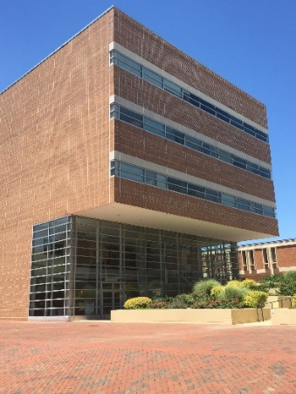The North Carolina Citizens Committee presented Reese with the 1974 Distinguished Citizenship Award. Reese also served on the boards of trustees for both the University of North Carolina and UNC Charlotte, serving as the chair of the latter from 1972 until his death in 1977.

Like the Colvard Building, the Reese Administration Building was designed by Harry Wolf of Wolf Associates. It was completed in 1982, and is named in Reese’s honor.

Today, Reese houses the office of the Vice Chancellor for Business Affairs, Financial Services, the Office of Financial Aid, and the Graduate School.

**Robinson**

Robinson Hall for the Performing Arts is a state-of-the-art venue that affords the campus and the community access to a slate of contemporary and classical dance, music and theater offerings.

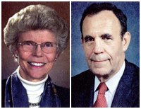Named for Russell and Sally Dalton Robinson, the three-story, 118,000-square-foot facility contains classrooms, offices and performance and rehearsal spaces for the departments of dance, music and theatre. It was built and equipped for $28 million, financed through the statewide bond referendum approved by voters in 2000.

The hall’s first floor houses a 332-seat proscenium theater, which includes a 23-seat orchestra pit. The theatre has a 3,500-square-foot stage equipped with 18 trapdoors, a curtain 26 feet high and a 60-foot fly-loft for storing and changing scenery. There also is the Black Box Theatre. Throughout the building are rehearsal rooms and labs for costume, scenery and lighting design.

The Robinsons are both Charlotte natives, and they are considered among the most admired and effective community leaders. In addition to leadership roles at Christ Episcopal Church, they have supported professional, educational and charitable institutions, arts and cultural organizations and economic development services.

Russell Robinson II is founding partner of one of North Carolina’s largest law firms - Robinson, Bradshaw and Hinson. According to an article in the Charlotte Observer, Robinson majored in English at Princeton University but transferred to Duke University after two years. He went on to obtain his law degree from Duke in 1956. His firm has represented numerous businesses and organizations, including Belk Store Services Inc., the Duke Endowment, Duke Power and the Charlotte Housing Authority. His book “Robinson on North Carolina Corporation Law” is considered a necessity for any aspiring Tar Heel corporate lawyer.

A member of the UNC Charlotte Board of Trustees from 1987-97, Robinson served as chair for eight years. During his board tenure, Robinson was regarded by observers as a “quiet power” for the University; he focused on increasing public and private funding and obtaining UNC system authorization for doctoral degrees beyond joint Ph.D. programs.

In addition to his role as a trustee, Robinson was a director of the UNC Charlotte Foundation. He also has been a trustee of the Duke Endowment and chair of Duke University’s Board of Trustees.

Sally Dalton Robinson attended public schools in Charlotte, St. Mary’s School in Raleigh and Duke University. She was a member of Phi Beta Kappa and earned a bachelor’s degree in history. Among her many civic contributions, she served as an integral founding member of the Levine Museum of the New South and the St. Francis Jobs Program (now the BRIDGE Jobs Program). She also was on the board of the Charlotte Symphony, the Arts and Science Council, McColl Center for the Visual Arts as well as other religious, charitable and economic organizations.

Dedicated November 3, 2004, Robinson Hall was designed by the Charlotte architectural firm of Jenkins Peer. Skanska and R.J. Leeper were general contractors, while the firm Biemann and Rowell was the mechanical contractor. Port City Electric served as the electrical contractor; the hall’s lighting and acoustical controls were among the most sophisticated in modern theater design at the time of construction.

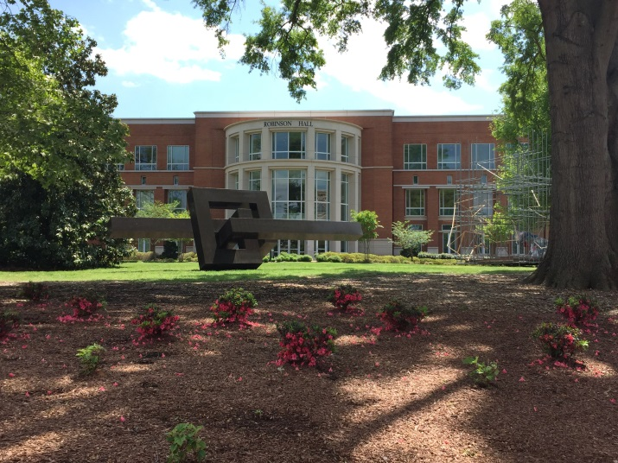

Today, Robinson Hall is home to the Departments of Dance, Music, and Theatre; the Anne R. Belk Theater; and the Lab Theater.

**Rowe**

The Oliver Reagan Rowe Arts Building honors one of UNC Charlotte’s founding fathers. Completed in 1971, the 75,000 square-foot facility was constructed to house the-then departments of Performing and Visual Arts. The building’s focal point is an eight-sided theatre that seats 350. It also includes a recital hall, classrooms, offices, practice rooms and a large lobby-gallery.

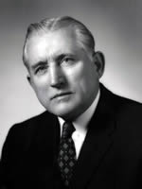Rowe was born Dec. 12, 1902, in Newport, Tenn. He and his wife Maria would become avid supporters of the Charlotte arts community and UNC Charlotte. Rowe’s family moved to Charlotte when he was a child. After graduating from Central High School, Rowe attended UNC-Chapel Hill, where he completed a bachelor’s degree in electrical engineering. He returned to Charlotte and began work with the R.H. Bouligny engineering firm. He eventually became president of R.H. Bouligny Inc., Powell Manufacturing Co. and Powell Agri-Systems Ltd.

In the 1950s, Rowe supported consolidation of city and county schools, which won him the Charlotte News “Man of the Year Award” in 1958. That same year, Gov. Luther Hodges appointed Rowe to the first Board of Trustees for the Charlotte Community College System. He chaired the board’s finance committee, and he was instrumental in soliciting the largest single gift to the-then Charlotte College Foundation (now the Foundation of the University of North Carolina at Charlotte).

Between 1961 and 1963, Rowe made numerous speeches championing the cause of higher education for the Charlotte region. In 1964, the Charlotte Civitan Club presented its Distinguished Citizenship Award in recognition of Rowe’s efforts on behalf of the University.

During the rest of the 1960s, Rowe continued to find new causes for his leadership. A long-time music lover, Rowe began to support the opera and symphony. Eventually, he was elected president of the Charlotte Symphony Orchestra Society, and in 1973, he established, nurtured and financially supported the “Rowe String Quartet” at UNC Charlotte.

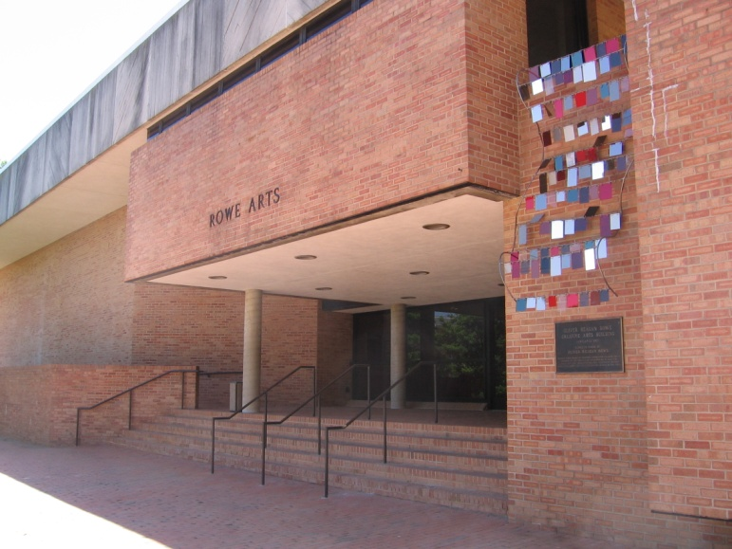

In 1987, Rowe was awarded an honorary Doctor of Human Letters. The citation reads in part that “Oliver Reagan Rowe Sr. was a founding father of the University of North Carolina at Charlotte. He helped to dream the dream and to make it come true … With his vision, he painted a picture of a major state university when others around him saw only the two-year college then existing.”

Today, the Rowe Building is home to the Department of Art and Art History.

**Smith**

The Sheldon Phelps Smith Building honors an individual whose foresight helped to chart UNC Charlotte’s educational course.

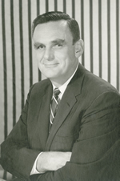Smith, vice president and general manager of the Douglas Aircraft Company’s Charlotte Division, served as a trustee of Charlotte College from 1958 to 1965. He is credited with bringing an engineering program to the institution. Through his generosity, Douglas Aircraft Co. engineers taught at Charlotte College on a released time basis; as many as nine part-time instructors from Douglas were in service at one time.

Born in Redlands, Calif., on March 26, 1910, Smith graduated from Pomona College in 1932 with a bachelor’s degree in physics. During World War II, he served as a lieutenant with the Engineering Division of the Navy Bureau of Aeronautics and was assigned to the missiles branch. Following the war, he was a missile project engineer with the Douglas Aircraft Co. Prior to moving to Charlotte, he was an assistant design engineer for missiles at the company’s Santa Monica facility.

In addition to starting the University’s engineering program, Smith is credited with bringing graduate courses in mathematics and physics to the-then Charlotte College through a cooperative agreement with N.C. State University.

As an advocate for the college, Smith once said, “If we marry the manpower development of this Charlotte College area of some 1 million people to the tremendous demand of technical industries for engineers and scientists, we will accomplish two ends: to help satisfy the great national requirements for engineers and scientists and to improve the usefulness and economic standards of the residents of North Carolina.”

Smith left Charlotte to become vice president of Douglas Aircraft and vice president of Douglas United Nuclear Corp. in Hanford, Wash. He died April 28, 1966.

The Smith Building, completed in 1966, was originally called the Engineering Building. The 71,000 square-foot, $1.6 million facility was the largest classroom and laboratory building on the campus at the time. When finished, it housed the Computer Center, Mathematics Department, the Geography and Geology Department (now Department of Geography and Earth Sciences) and the Engineering Program.

UNC Charlotte dedicated the building in honor of Smith on Dec. 15, 1968, in a ceremony held in the Cone University Center. The Smith family presented a portrait of the building’s namesake to be placed in the facility.

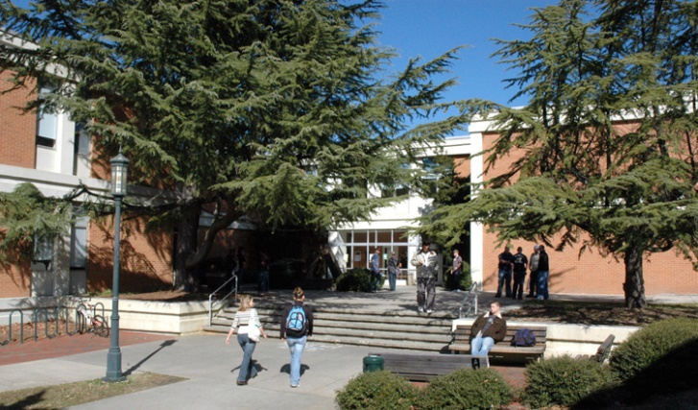

The Smith building is one of the five buildings that make up the original quad of UNC Charlotte. Today, Smith is home to the College of Engineering’s Office of Student Development and Success, Mosaic Lab, and the Department of Engineering Technology and Construction Management.

**Storrs**

The Thomas I. Storrs Building resulted from the collaboration between Charlotte architectural firm Ferebee, Walters and Associates and New York architects Charles Gwaltmey and Robert Siegel.

Since its completion in 1990, Storrs Building has been used as an “architectural education instrument,” because students and professionals can study its many unique features, as the building is considered a virtual textbook for use of materials and systems. This 87,000-square-foot facility features a complex roof design, natural and artificial lighting systems, double helix stairs and exposure of structural and environmental systems. Home to the School of Architecture in the College of Arts and Architecture, Storrs Building is appropriately named for an individual who dedicated himself to helping build the University.

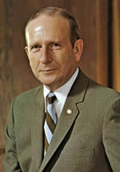Storrs, born in 1918, dropped out of high school during the Great Depression. At the age of 15, he began work as a clerk at the Federal Reserve Bank of Richmond, Va. He would later resume his formal education, enrolling in the University of Virginia, where he completed undergraduate studies. He earned a master’s degree and doctorate in economics from Harvard University.

Originally from Nashville, Tennessee, Storrs joined the-then North Carolina National Bank (NCNB) in 1960 as executive vice president. He would later serve as one of the architects who laid the foundation for NCNB to emerge as NationsBank (now Bank of America). Following the retirement of Addison Reese, Storrs became chair and CEO, and he would follow his predecessor’s example as a member of the UNC Charlotte Board of Trustees for nearly 12 years – the last four years as chair. His civic involvement included serving as president of the Business Foundation of North Carolina, vice president of the North Carolina Engineering Foundation and director of the North Carolina Textile Foundation. In 1990, he was inducted in the North Carolina Business Hall of Fame.

A recipient of the UNC Charlotte Distinguished Service Award, Storrs also has a scholarship in his name at the University of Virginia.

Formal groundbreaking for the $7.5 million Storrs Building was held Aug. 26, 1988. Dedication of the building was Oct. 29, 1990, and a ceremony to name the facility in honor of Storrs was held Sept. 16, 1992.

Today, the Storrs Building is home to the College of Arts + Architecture and School of Architecture.

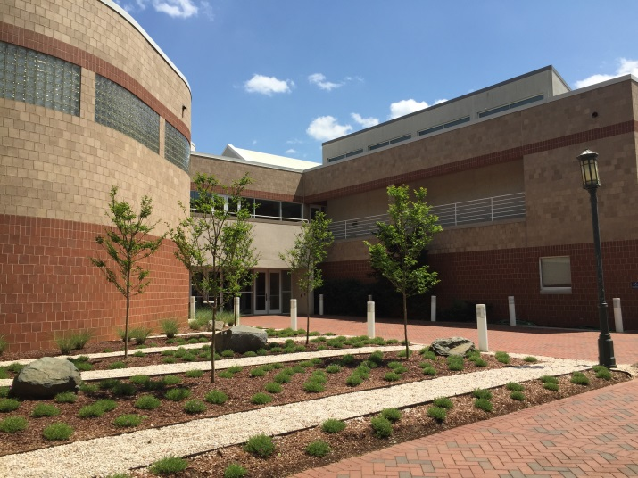

**Winningham**

If one person can be credited for launching the tradition of bringing prominent speakers to the UNC Charlotte campus, then it is Edyth Farnham Winningham, one of the University’s pioneering faculty members.

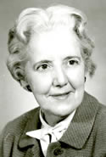

Winningham, born Jan. 26, 1900, in Arthur, N.D., earned a bachelor’s degree in modern languages from the University of North Dakota. She later earned a master’s in political science from UNC-Chapel Hill, reportedly the first woman in the state to complete the degree.

Beyond teaching high school in North Dakota and North Carolina, Winningham served as a faculty member at the University of Wyoming, the Women’s College of the University of North Carolina (now UNC Greensboro) and the UNC College Center in Wilmington (now UNC Wilmington). Her connection to UNC Charlotte dates back to its time as Charlotte College. Winningham joined the faculty in 1947, and she spent the next two decades infecting everyone around her with her passion for politics and international affairs.

Winningham frequently stated that one of her dreams was to bring prominent thought-leaders to the campus to “open up windows” for the institution’s students. Her persistence paid off in 1966 with the establishment of the University Forum Council, which sponsored an event each year to bring noted speakers to the campus to address crucial issues facing contemporary society. She chaired the council until spring 1971, despite retiring in 1967 as professor emeritus. According to Special Collections, the final forum was held March 2, 1995. This 30th annual event focused on “Violence: Is Prevention the Key?”

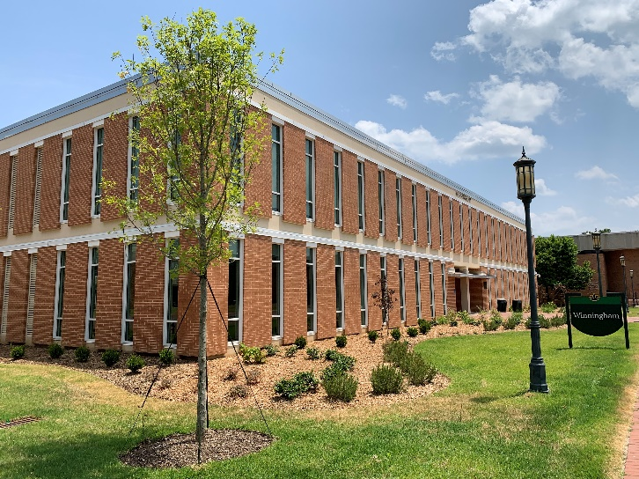

Even after retiring, Winningham continued to lecture on world affairs and international education. She and her husband also established the James and Edyth F. Winningham Scholarship for undergraduate political science majors.

In 1970, Winningham’s service to the greater Charlotte community was recognized by the League of Women of Voters. The organization singled her out for her instrumental role in forming closer ties between the University and the Charlotte community at large, and she was named WBT Radio’s Woman of the Year. In 1985, UNC Charlotte awarded her an honorary Doctor of Humane Letters. She died May 27, 1994.

The 10,507-square-foot classroom building which bears her name was constructed in 1965 by F.N. Thompson Inc. The architectural firm Odell Associates designed the facility.

The Winningham building is one of the five buildings that make up the original quad of UNC Charlotte. Today, Winningham is home to the Department of Art & Art History, and Philosophy.

**Woodward**

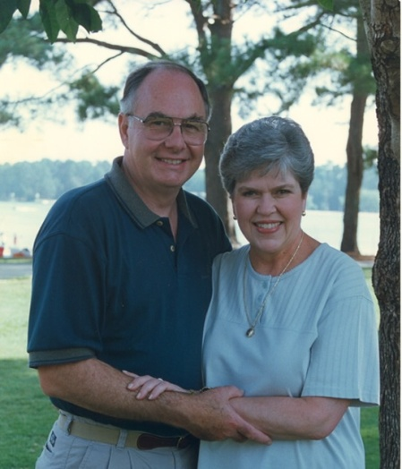As students at UNC Charlotte attend classes in the science and technology building on campus, they are walking into the physical manifestation of the work done by Chancellor Emeritus James Woodward and his wife Martha. On November 16, 2005, the building was formally dedicated to recognize the Woodwards’ 16 years of service and devotion to the University.

The James H. and Martha H. Woodward Hall is a direct result of their vision to help elevate UNC Charlotte to a research institution. The Woodwards worked together to raise awareness of the University’s vital role as an economic engine and build many new partnerships and friendships for the institution. As Chancellor from 1989 to 2005, Jim Woodward was the visionary, strategist, and master builder who guided UNC Charlotte’s development as a major research institution. Martha played a vital role in strengthening ties to UNC Charlotte through the hosting of thousands of guests regionally and nationally. Throughout their 16 years at the University, the Woodwards worked together to bring much needed attention to both the University’s strengths and to its resource needs.

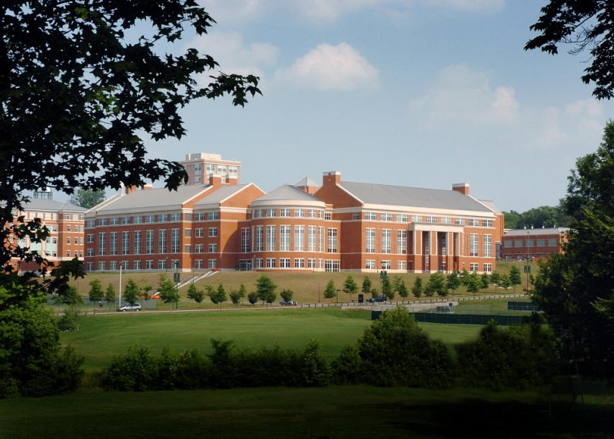

Today, Woodward Hall is home to the College of Computing and Informatics; and Departments of Biological Sciences, Computer Science, Mechanical Engineering & Engineering Science, and Software & Information Systems.

**University Logo**

In 2021, UNC Charlotte adopted the All-in-C logo, which features a block-style letter C with a pickaxe (used by Charlotte mascot Norm the Niner). The design pays tribute to the University’s trailblazing spirit. The All-in-C represents the power to break new ground, the persistence to discover the unknown, and the promise to build the future.



**University Seal**

UNC Charlotte became the fourth campus of the University of North Carolina in July of 1965. In the fall of 1965, the new UNC Charlotte seal was chosen by a committee of students (the three upper-class presidents), three faculty members, and the school publicity director, who served as chair. Final approval was given by Acting Chancellor Bonnie Cone.

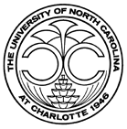UNC Charlotte seal’s elements are: the modern arches (the tulip design from the canopy of the Kennedy Building) at the top to symbolize that this is a twentieth century university; two Cs in the middle to represent Charlotte College, from which the new campus sprang; and the pine cone at the bottom for the Old North State [land of the longleaf pine]. The date on the seal is 1946, the year in which the institution began as the Charlotte Center of the University of North Carolina.

**Alma Mater**

j0329307[1]UNC Charlotte's Alma Mater has deep roots in the institution's history. It was part of an "Academic Festival March" composed for UNC Charlotte by James Helme Sutcliffe, a Charlotte composer and music critic who lived in Germany at the time. Dr. Loy Witherspoon, professor of religious studies, commissioned the March in 1965 when he learned that Charlotte College would become a campus of The University of North Carolina. The March was first performed in 1967 at the installation of Dean W. Colvard as UNC Charlotte's first chancellor. Afterwards, it was performed as a recessional at every Commencement during Dean W. Colvard's tenure as chancellor. When UNC Charlotte founder Bonnie Cone heard the March, she said, "I can hear an alma mater in it," referring to a hymn-like refrain. Dr. Robert Rieke, a professor of history, also heard an alma mater in it.

On a 1990 trip to Germany, Rieke visited Sutcliffe, picked up a recording of the March, and began writing words to fit the final refrain. On Christmas Eve 1991, he sent Bonnie Cone the words and music as a Christmas present to her and to the University, from which he had retired a year earlier. Chancellor James H. Woodward approved the composition as the University's Alma Mater in April 1992. It was sung for the first time at the following May Commencement and has been performed at every Commencement since.

*Hail University! To you we sing our praise.*

*May Charlotte’s light dispel the night,  
illumine all our days.*

*In Carolina’s crown the brightest gem we see.*

*Without your power our finest hour  
would hold no victory.*

*So let us love your life and  
cherish your great name.*

*To aid your cause, uphold your laws,   
and your enduring fame.*

**The 49ers**

The nickname, the 49ers, was chosen in recognition of the importance of the year 1949 in the history of the University. UNC Charlotte, which began as an off-campus center of the University of North Carolina at Chapel Hill, would have closed its doors in 1949 had Bonnie Cone and her supporters not convinced the N.C. Legislature that Charlotte needed a permanent college. Charlotte College was established that year. Additionally, the campus is located on N.C. Highway 49, and Charlotte has a rich gold mining history -- the term "49ers" symbolizes gold mining. A bronze statue of the 49ers Gold Miner sits at the bottom of the staircase between the College of Education and College of Health and Human Services buildings on campus. The statue recalls the region's history as a gold mining center and symbolizes the pioneering spirit and determination that has led to UNC Charlotte's dramatic growth.

**49ers Fight Song**

The fight song music was composed by former music faculty member Dr. Harry Bulow in 2001. It replaced one which belonged to the University of Texas at Austin, entitled "Texas Fight," which had been used since the late 1960's. The new fight song was played for five years before Dr. Laurence Marks, UNC Charlotte's director of bands, composed a set of lyrics in 2006. Minor changes suggested by the campus administration, Athletics, and students were accepted by Marks and submitted for final approval by the Chancellor and the 49ers Fight Song, reflected below, was born.

*Hail, Charlotte 49ers, proud as we can be*

*We stand to fight for the green and white,  
Til we win the Victory (Go Niners!)*

*We pledge our trust in you,*

*And wave your colors high*

*The loyal Niner Nation cheers,*

*Forever! We'll Fight-Fight-Fight!*

**Mascot**

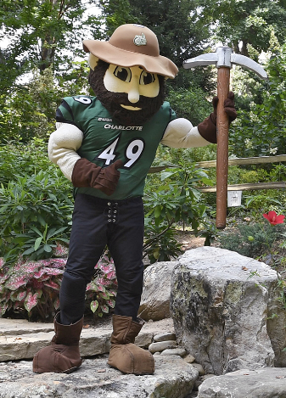A miner was chosen as the UNC Charlotte mascot as a nod to Reed Gold Mine in nearby Concord, the site of the first documented gold find in the United States in 1799. He was named Norm through popular student vote shortly after he was made mascot. Norm is rarely seen without his trusty pick-axe and never takes his slouch hat off.